Activity Pages

Week 1
- The Design Process

Week 2
- Shoe Design Challenge
- IDEO’s Seven Principles of Brainstorming

Week 3
- Storyboard Template (also used in Week 6)
- Storyboard Examples

Week 4
- Websites for Flying Objects
- How Far Does Your Flying Object Fly??

Week 5
- Checklist for the Perfect Hangout (also used in Week 6, 7)

Week 6
- Storyboard Template (also used in Week 3)

Week 7
- Checklist for the Perfect Hangout (also used in Week 5, 8)

Week 8
- Checklist for the Perfect Hangout (also used in Week 5, 7)

The Design Process
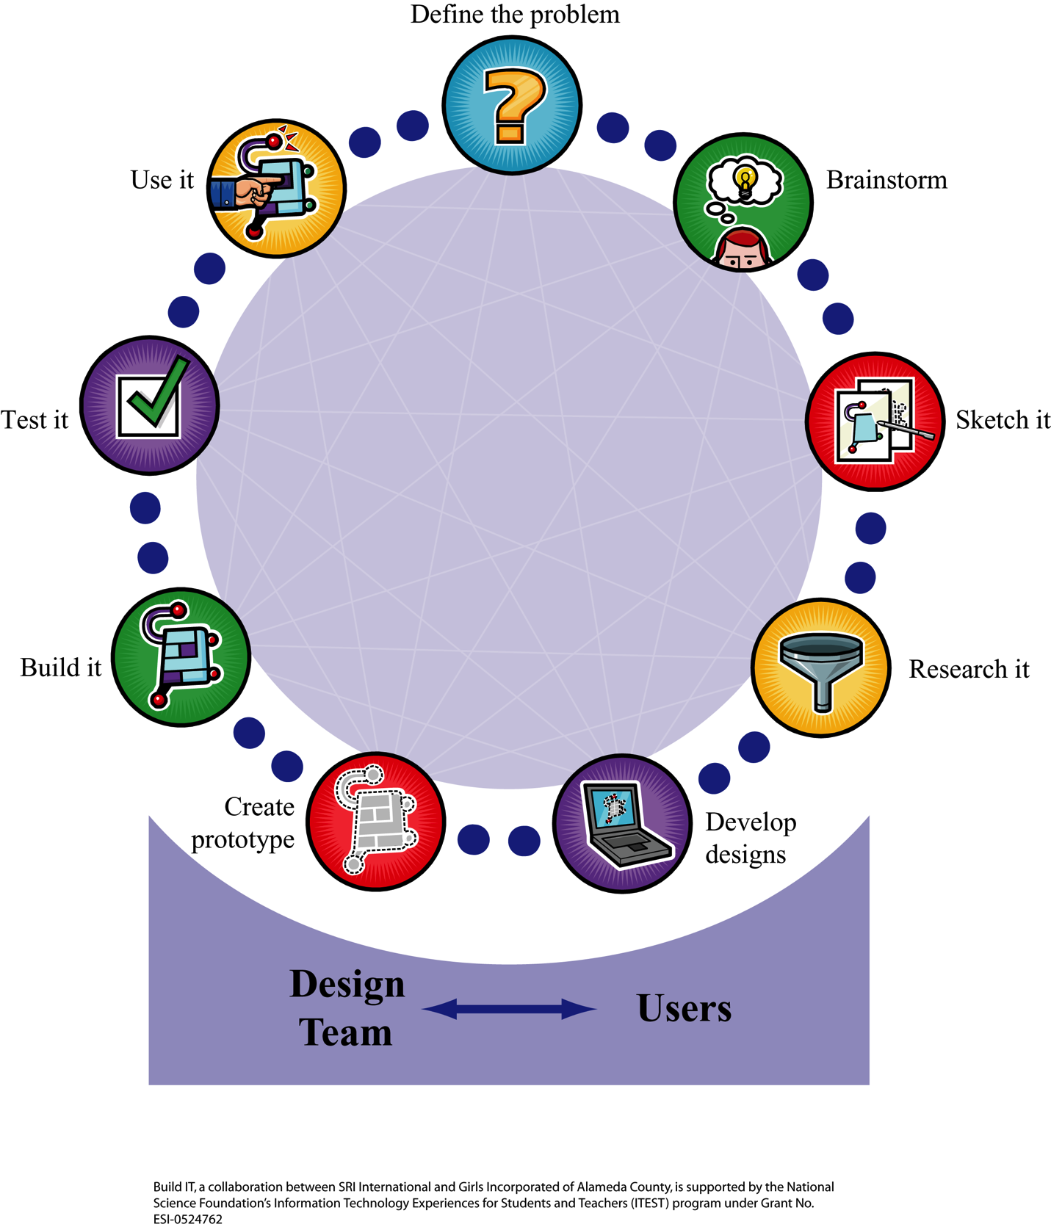

Shoe Design Challenge
- Identify the user of the shoe.
- Identify the problem that user has.
- Describe how the shoe will address the problem.
- Write down your ideas in your Design Notebooks—you will need this information during the next session.
- Draw sketches of how the shoes will look (form) and perform (function).

IDEO’s Seven Principles of Brainstorming
- Defer Judgment: no telling your neighbor you don’t like their idea
- Encourage Wild Ideas: the crazier, the better
- Build on the Ideas of Others
- Stay Focused on the Topic
- One Conversation at a Time: it’s rude to speak while someone else is speaking—plus you might miss hearing a good idea
- Be Visual: sometimes it’s easier to express yourself in a picture than with words
- Go for Quantity: you want lots of ideas, and you’ll worry about quality later.

Storyboard Template (print large enough for youth to use)
Project Title ___________________________________________________________
Screen Number ______________  Screen Sketch  Describe the Action  ________________________________________________  ________________________________________________  ________________________________________________ | Screen Number ______________  Screen Sketch  Describe the Action  ________________________________________________  ________________________________________________  ________________________________________________
Screen Number ______________  Screen Sketch  Describe the Action  ________________________________________________ ________________________________________________  ________________________________________________ | Screen Number ______________  Screen Sketch  Describe the Action  ________________________________________________  ________________________________________________  ________________________________________________
Screen Number ______________  Screen Sketch  Describe the Action  ________________________________________________  ________________________________________________  ________________________________________________ | Screen Number ______________  Screen Sketch  Describe the Action  ________________________________________________  ________________________________________________  ________________________________________________

Storyboard Examples

Example 1
Different people can make different storyboards for the same design. See different storyboards for scientific oven mitts, from the MIT Museum.
http://web.mit.edu/2.744/www/Project/Assignments/conceptSketches/design-o-mite/storyboard/mitt-story.html

Example 2
Storyboard of how a software feature works
http://www.csc.calpoly.edu/~jdalbey/205/Deliver/StoryboardExamples.html#1

Example 3
Storyboards are also used to tell a story. You can use them to tell how a machine is used by users.
http://youthlearn.org/activities/using-storyboards-thinking-through-visual-storytelling

Example 4
Storyboards for how a machine works: “Understanding Your Automobile” examples
http://www.mcli.dist.maricopa.edu/authoring/studio/guidebook/storyboard_example.html

Websites for Flying Objects

Boomerang
History: http://www.rangs.co.uk/boomhistory.htm
How it works: http://www.rangs.co.uk/howaboomworks.htm
How it is made: http://inventors.about.com/library/inventors/blboomerang.htm

Frisbee
History: http://www.ideafinder.com/history/inventions/story008.htm
http://inventors.about.com/library/weekly/aa980218.htm
How it works: http://wings.avkids.com/Book/Sports/instructor/frisbee-01.html
http://www.montshire.org/minute/mm010902.html=
How it is made: http://www.enquirer.com/editions/2004/07/20/biz_biz1whamo.html
http://www.frisbeedisc.com/products/index.html
http://www.pet-shop.net/html/frisbee.html

Aerobie
History: http://www.aerobie.com/History.htm
How it works & is made: http://www.aerobie.com/Science.htm

How Far Does Your Flying Object Fly??
Every time you throw a flying object, it travels a different distance. One way we can figure out how well a design works is by measuring individual throws and taking an average.
AVERAGE = | Sum of throws
 | Number of throws
Object 1:  ____________ |  | How far did it go?  Calculate the average here by adding the 3 throws and dividing by 3
Youth 1,Throw 1
Youth 2,Throw 2
Youth 3,Throw 3
AVERAGE |  | Calculate the average here by adding the 3 throws and dividing by 3

Object 2:  ____________ | How far did it go?
Youth 1,Throw 1
Youth 2,Throw 2
Youth 2,Throw 3
AVERAGE
Remember: measure using a common unit, so that you can compare your information with the other teams.
AVERAGE = | Sum of throws
 | Number of throws
Other teams may have also tested the same object. Write down all the averages for all the objects and calculate a final average (by adding the 2 averages and dividing by 2).

 | Name | Average 1 | Average 2 | Final Average
Object 1
Object 2
Object 3
Object 4
Object 5
Object 6

Now you have more information to help you decide design your own flying object!

Checklist for the Perfect Hangout

Your Design Plan
For the design plan, do the following:
□ Communicate your design effectively to users.
□ Use materials given, not ones created by the group.
□ Identify what each object is.
□ Include three types of technology, real or invented, with information on what each technology does.
□ Show the borders of the room and how one enters or leaves the room.
□ Show how the objects are arranged in space.

Your Presentation
For the presentation, do the following:
□ Describe the client’s needs and include quotations from the client describing those needs.
□ Explain the function of each object in the room.
□ Explain why objects are arranged the way they are.
□ Describe how the design meets the client’s needs and include quotations from the client describing whether or not the design meets those needs.
□ Describe how a user might use the room on a typical day.

