# The ICT4me Curriculum

## About ICT4me

ICT4me is an after school and summer curriculum for middle school youth to develop ICT fluency, interest in mathematics, and knowledge of information, communication, and technology (ICT) careers. This problem-based curriculum capitalizes on youth interest in design and communication technologies. ICT4me provides structured interactions with ICT professionals, including having youth participate in engineering design and development teams. ICT4me's promotes a train-the-trainer approach to building capacity in informal ICT learning.

**Build IT vs. ICT4me**

ICT4me is a derivative of the Build IT curriculum co-developed between SRI International and Girls Inc. of Alameda County. Questions about the Girls Inc. implementation of Build IT can be directed to them at <http://www.girlsinc-alameda.org/about/contact>.

SRI is no longer supporting the development of ICT4me, so the curriculum materials are offered as is.

## Copyright

Copyright © 2016 by SRI International. All rights reserved.

## Attribution

This material is based upon work supported by the National Science Foundation under Grant Nos. 1339181, 1232461, and 0524762. Any opinions, findings, and conclusions or recommendations expressed in this material are those of the author(s) and do not necessarily reflect the views of the National Science Foundation.

## Electronic Versions of Materials

Electronic versions of all materials in this unit are available for download from the website at <http://ict4me.sri.com/>.

## Contact Information

Please contact the SRI International Inquiry line for questions about ICT4me.

<https://www.sri.com/contact/form>



Activity Pages

Week 1: Activity Pages

Put the Design Process in order

Web and Foundation Graphics

The Design Process

Website Design Requirements

Designing Your Website

Sketch your 1st page

Writing on page 1

Sketch your 2nd page

Writing on page 2

Sketch your 3rd page

Writing on page 3

Sketch your 4th page

Writing on page 4

Theme Ideas

Week 3: Activity Pages

* Website Design Requirements
* Setting Up an HTML File
* Placing Images & Headers
* Hyperlinks
* Images

Week 6: Activity Pages

* Website Design Requirements Checklist
* Web Color Codes
* Color Your Web Pages Handout
* Color Cards

Week 8: Activity Pages

* WYSIWYG Drawing Checklist
* WYSIWYG Page 1
* Answer to WYSIWYG Page 1
* WYSIWYG Page 2
* Answer to WYSIWYG Page 2
* WYSIWYG Page 3
* Answer to WYSIWYG Page 3

Week 10: Activity Pages

* Website Design Requirements Checklist

Put the Design Process in order

|  |  |  |
| --- | --- | --- |
| **Description: 02brainstorm**  **Brainstorm it** | **Description: 07build**  **Build it** | **Description: 09use**  **Test it** |
| **Description: 03sketch**  **Sketch it** | **Description: 05developDevelop design** | **Description: 01define**  **Define the problem** |
| **Description: 04research**  **Research it** | **Description: 08test**  **Test it** | **Description: 06prototype**  **Create prototype** |

Web and Foundation Graphics





The Design Process

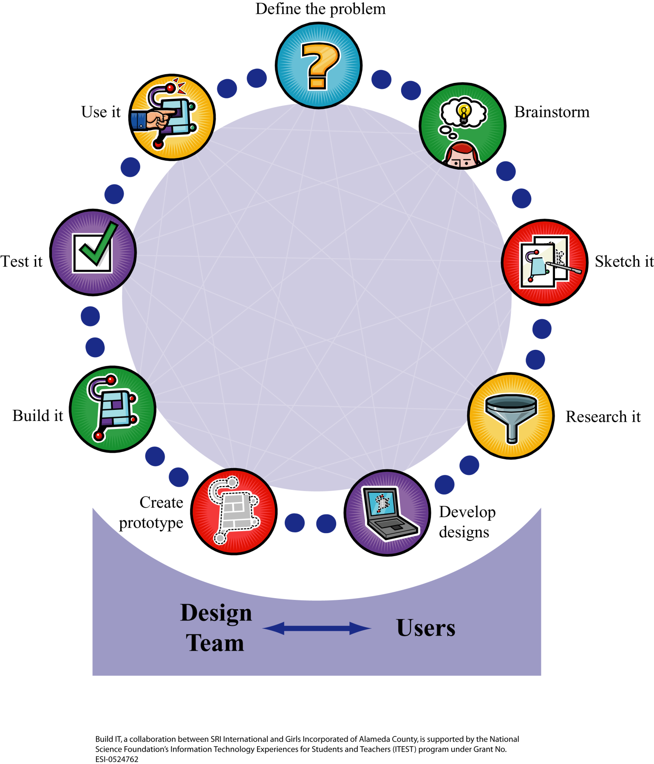Website Design Requirements

* Does your website have a theme?
* Does your theme include a need for a chat or IM feature?
* Does your website have at least 4 pages?
* Do your web pages link (connect) to each other?
* Does your website have at least 2 links to outside websites? Do the outside websites have to do with your theme?
* Do users know how to use your website or how to get around (navigate)
* Does one page have information about you (the engineer/ creator/ designer) of the website?
* Does your website have 2 images that have to do with your theme?
* Do your pages have a similar look? Can users tell that all pages are part of the theme?

Note: Design Requirements are adapted from Introduction to Computing Bermuda Information Technology Course Track. Developed by Stanford University Computer Science Department.

Name

Designing Your Website

Define the problem

Who is your audience?

What are they looking for when they come to your website?

Why do they want to come to your site to communicate or chat?

Brainstorm

What theme do you think your audience will like?

**Sketch your 1st page**

Web browser title goes here

Information about your theme

**Sketch Check List:**

* Where will you place your header (web page title -goes in the white space)?
* Where will you have your horizontal lines?
* Where will you place your internal hyperlinks (navigation)
* Where will you place your external hyperlinks (outside websites)
* Where will you place your text?
* Where will you place your images?
* What color is your font?

What color is your background?

**Writing on page 1**

Web page title:

(Header-<hr>)

Information about your theme

(Please write in complete sentences)

**Sketch your 2nd page**

Web browser title goes here

Information about your theme

**Sketch Check List:**

* Where will you place your header (web page title -goes in the white space)?
* Where will you have your horizontal lines?
* Where will you place your hyperlinks (internal and external)?
* Where will you place your text?
* Where will you place your image?
* What color is your font?
* What color is your background?

**Writing on page 2**

Web page title

(Header-<hr>)

Information about your theme continues

(Please write in complete sentences)

**Sketch your 3rd page**

Web browser title goes here

Information about the designer

**Writing on page 3**

Web page title:

(Header-<hr>)

Information about yourself

(Please write in complete sentences)

**Sketch your 4th page**

Web browser title goes here

Chat feature and how it fits into your website

**Writing on page 4**

Web page title:

(Header-<hr>)

Your chat feature

(Please write in complete sentences)

Theme Ideas

* Think about what interests you and your friends. Is it a topic you, your friends, and others might like to talk about? If you answered yes, that’s a theme!
* Here are a few ideas you can use to get started or you can refine an idea you already have:
* **HipHop Music** (or any specific type of music). You could share music, performance schedules, and discuss the bands that you like.
* **Softball League**. You could share local game schedules, scores, and discuss strategies.
* **Labrador Retrievers**. Share photos, training tips, and get advice on raising your Labrador.
* **Teenagers from Mexico**. Users can share their Mexican heritage; discuss where they live now and their Mexican connection.
* **Beyoncé Fan Club**. You can share her music and discuss her songs and performances.

Website Design Requirements

* Does your website have a theme?
* Does your website have at least 4 pages?
* Do your web pages link (connect) to each other?
* Does your website have at least 2 links to outside websites? Do the outside websites have to do with your theme?
* Do users know how to use your website or how to get around (navigate)
* Does one page have information about you (the engineer/ creator/ designer) of the website?
* Does your website have 2 images that have to do with your theme?
* Do your pages have a similar look? Can users tell that all pages are part of the theme?

Setting Up an HTML File

Start by typing this in your blank page.

**<html>**

**<head>**

**</head>**

**<body>**

**</body>**

**</html>**

* Every new page should begin with the <html> tag

____________________________

* The tags should always go in this order.

Placing Images & Headers

Place images on the left, right, top, bottom, or middle.

<img src= “flower.gif” align= “right”/>

Appears as:

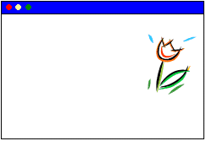

Type in where you want to place the image.

----------------------------------------------------------

Want to place headers in the center?

<h1 align= “center”> Summer Fun </h1>

Appears as:

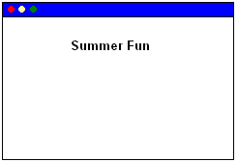

Hyperlinks

Use the anchor tag to create a hyperlink.

Text Wrangler: <a href= “http://www.google.com”> Google</a>

Website: Google

---------------------------------------------------

Make a link to a web page in your folder.

Text Wrangler:<a href= “bec_home.html”> Main</a>

Website: Main

Type in the name of your HTML file.

Images

Want a around your image?

Border

<img src= “flower.gif” border= “2”/>

Appears as:

Description: MCj02902800000[1] (style= “border-color: yellow”)

Want a thicker border? Put a bigger number.

-------------------------------------------------------

Want to change the size of an image?

<img src= “flower.gif” width= “50%”/>

On Website:



Change the size by entering the percentage of the original image size that you want your image to be.

Website Design Requirements Checklist

Top of Form

□ Does your website have a **theme**?

□ Does your website have at least **4 pages**?

□ Do your web pages **link (connect) to each other**?

□ Does your website have at least **2 links to outside** websites? Do the outside websites have something to do with your theme?

□ Do users know **how to use** your website or how to get around (navigate)?

□ Does one page have **information about you (the engineer/creator/designer)** of the website?

□ Does your website have **2 images** that have to do with your theme?

□ Do your pages have a **similar look**? Can users tell that all pages are **part of the theme**?

Web Color Codes

There are 16 “official” colors to use on the Web that W3C (also known as the World Wide Web Consortium, the governing body for web standards) recommends. See them all here at <http://www.w3.org/TR/html401/types.html#h-6.5>

**Color names and sRGB (**standard red green blue) **values**

|  |  |  |  |
| --- | --- | --- | --- |
|  | Black = "#000000" |  | Green = "#008000" |
|  | Silver = "#C0C0C0" |  | Lime = "#00FF00" |
|  | Gray = "#808080" |  | Olive = "#808000" |
|  | White = "#FFFFFF" |  | Yellow = "#FFFF00" |
|  | Maroon = "#800000" |  | Navy = "#000080" |
|  | Red = "#FF0000" |  | Blue = "#0000FF" |
|  | Purple = "#800080" |  | Teal = "#008080" |
|  | Fuchsia = "#FF00FF" |  | Aqua = "#00FFFF" |

Color Your Web Pages Handout

**Activity 1.** Predict how many combinations you could make if you had these 16 colors for background and the same 16 colors for text.

**Activity 2.** How many color schemes (combinations) are there, all together? We can figure out using math. But let’s break it down into steps. Figure out each of these with your color cards.

1. Choose **2 text** colors and **2 background** colors.
2. Predict how many combinations you can have? __________
3. Using your cards, find out if your prediction was correct.
4. Choose **3 text** colors and **3 background** colors.
5. Predict how many combinations you can have. __________
6. Show them using your color cards.
7. Now choose **2 title** colors, **2 text** colors and **2 background** colors.
8. Predict how many color combinations you will have. ____________
9. Lay out your possible color schemes using your color cards. How do you know you have all of the schemes? How many color schemes will you have?
10. Now choose **3 title** colors, **3 text** colors, and **3 background** colors.
11. Predict how many color schemes you can have? __________
12. How do you know? Show your work without using the color cards.
13. Verify your answer. Lay out your possible color schemes using your color cards.
14. How many color schemes will you have? ________
15. Now look back at your work for a, b, c, and d. What patterns do you see?

Do the number of color choices you have tell you how many color combinations or color schemes you will get? Is there some kind of math that can help you figure it out?

What is a rule for figuring out how many color schemes there are, if you know the number of choices for title, text and background? (Use words, symbols or both to figure it out).

1. Test out your rule by making up another set of choices.

Choose **2 title** colors, **5 text** colors, and **1 background** color.

Use your rule and also lay out the color cards. Does your rule work?

1. Now, go back to the first question we had. How many color combinations can you have if you have 16 background colors and 16 text colors? How do you know? What if you had 16 background colors, 16 text colors, and 16 title colors?

Color Cards

Use the following template and colored construction paper to cut out and color 16 backgrounds, 16 titles, and 16 texts in one of each of the 16 colors. [Alternatively, print these templates on colored paper.]

WYSIWYG Drawing Checklist

Your Drawing Should:

□ Show all of the elements depicted in the code

□ Show the elements in their proper placement on the page

□ Correctly identify font sizes and colors

□ Correctly identify format of the text (eg. plain, italics, or bold)

□ Correctly identify any images and draw (roughly) what they look like

When Your Group Has Finished, You Should:

□ Know what WYSIWG means

## WYSIWIG Page 1

<html>

<head>

<title>Singing about Race</title>

</head>

<body>

<h1><font color="red">Singing about Race</font></h1>

<center>

<font color = "red" size="+1">

<p>"Can you feel it<br>

Tension in the air<br>

Racism, violence everywhere<br>

Davis, Howard Beach<br>

Bumpers and Brawley<br>

It appalls me<br>

Now is there really racial justice<br>

It's time that we discussed this<br>

I'm disgusted and I don't trust this"<br>

</font>

<font size="-1"><b>Kool Moe Dee, "Pump Your Fist"</b></p></font>

<img src="http://o.scdn.co/300/31b4eac621c2aac0cda8c49fe2ebd776ca3ef592" width="20%">

<font color = "black" size="+1">

<p>"Emancipate yourselves from mental slavery<br>

None but ourselves can free our minds<br>

Have no fear for atomic energy<br>

Cause none of them can stop the time"<br>

<font size="-1"><b>

Bob Marley, "Redemption Song"

</b></font></p>

<img src="http://bobmarleyredemptionsong.com/wp-content/uploads/2013/02/redemptionsong.jpg" width="20%">

</center>

<font size="-1">

<p>To find more inspiring songs, go to <a href=”http://www.edchange.org/multicultural/arts/race_songs.html”> EdChange</a></p>

<p><b>WYSIWYG</b> means <i>What You See Is What You Get</i>. When something on a computer is WYSIWIG, it means that what you see on the computer screen is what you would see if you printed it or displayed it somewhere else.</p>

</font>

</body>

</html>

## Answer to WYSIWIG Page 1

**Singing about Race**

"Can you feel it  
Tension in the air  
Racism, violence everywhere  
Davis, Howard Beach  
Bumpers and Brawley  
It appalls me  
Now is there really racial justice  
It's time that we discussed this  
I'm disgusted and I don't trust this"

**Kool Moe Dee, "Pump Your Fist"**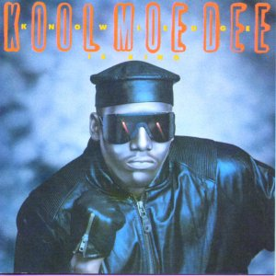

"Emancipate yourselves from mental slavery  
None but ourselves can free our minds  
Have no fear for atomic energy  
Cause none of them can stop the time"

**Bob Marley, "Redemption Song"**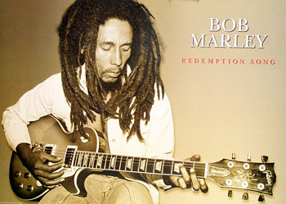

To find more inspiring songs, go to EdChange (http://www.edchange.org/multicultural/arts/race_songs.html)

**WYSIWYG** means *What You See Is What You Get*. When something on a computer is WYSIWIG, it means that what you see on the computer screen is what you would see if you printed it or displayed it somewhere else.

## WYSIWIG Page 2

<html>

<head>

<title>Singing about Immigration</title>

</head>

<body>

<h1><font color="green"> Singing about Immigration</font></h1>

<p><img src="http://cdn.songonlyrics.com/wp-content/uploads/2012/02/The-Battle-Of-Los-Angeles-1999-Rage-Against-The-Machine.jpg" align="left" width="20%"></p>

<font color="green" size="+2" align="left">

<p>"Tha sun ablaze as Maria's foot<br>

Touches tha surface of sand<br>

On northern land<br>

As human contraband<br>

Some rico from Jalisco<br>

Passed her name to tha boss<br>

She stuffed ten to a truckbed<br>

She clutches her cross"<br>

<font size="-1"><b>Rage Against the Machine, "Maria"</b></font></p>

</font>

<p><img src="http://images4.fanpop.com/image/photos/22300000/Lady-GaGa-Americano-Gif-lady-gaga-22386387-500-499.gif" align="right" width="20%"></p>

<font color="red" size="+2" align="right">

<p>"I met a girl in east LA <br>

In floral shorts as sweet as May <br>

She sang in eights in two barrio chords <br>

We fell in love, but not in court"<br>

<font size="-1"><b>Lady Gaga, "Americano"</b></font></p>

</font>

<font size="-1">

<p>To find more inspiring songs, go to <a href="http://www.edchange.org/multicultural/arts/race_songs.html">EdChange</a></p>

<p><b>WYSIWYG</b> means <i>What You See Is What You Get</i>. When something on a computer is WYSIWIG, it means that what you see on the computer screen is what you would see if you printed it or displayed it somewhere else. </p>

</font>

</body>

</html>

## Answer to WYSIWIG Page 2

**Singing about Immigration**



"Tha sun ablaze as Maria's foot  
Touches tha surface of sand  
On northern land  
As human contraband  
Some rico from Jalisco  
Passed her name to tha boss  
She stuffed ten to a truckbed  
She clutches her cross"

**Rage Against the Machine, "Maria"**



"I met a girl in east LA

In floral shorts as sweet as May

She sang in eights in two barrio chords

We fell in love, but not in court"

**Lady Gaga, "Americano"**

To find more inspiring songs, go to EdChange (http://www.edchange.org/multicultural/arts/race_songs.html)

**WYSIWYG** means *What You See Is What You Get*. When something on a computer is WYSIWIG, it means that what you see on the computer screen is what you would see if you printed it or displayed it somewhere else.

## WYSIWIG Page 3

<html>

<head>

<title>Singing about Stereotypes</title>

</head>

<body>

<h1><font color="blue">Singing about Stereotypes</font></h1>

<center>

<font color="blue" size="+2" align="right">

<p><img src="http://www.soulbounce.com/soul/assets_c/2011/11/queen-latifah-nature-of-a-sista-thumb-473xauto-9018.jpg" align="right" width="20%"></p>

<p>"Some think that we can't flow (can't flow)<br>

Stereotypes, they got to go (got to go)."<br>

<b>Queen Latifah, "Ladies First"</b></p>

</font>

<font color = "orange" size="+2" align="left">

<p><img src="http://popcultureblog.dallasnews.com/files/import/138021-En_Vogue_-_Funky_Divas_Cover-thumb-620x617-138020.jpg" align="left" width="20%"></p>

<p><i>"Oh now attitude, why even bother<br>

I can't change your mind<br>

You can't change my color<br>

Free your mind and the rest will follow"

</i><br>

<b>Funky Divas, "Free Your Mind" </b></p>

</font>

</center>

<p>

<font size="-1">

To find more inspiring songs, go to <a href="http://www.edchange.org/multicultural/arts/race_songs.html"> EdChange</a>

<p>

<b>WYSIWYG</b> means <i>What You See Is What You Get</i>. When something on a computer is WYSIWIG, it means that what you see on the computer screen is what you would see if you printed it or displayed it somewhere else.

</font>

</body>

</html>

## Answer to WYSIWIG Page 3

**Singing about Stereotypes**

"Some think that we can't flow (can't flow)  
Stereotypes, they got to go (got to go)."

**Queen Latifah, "Ladies First"**

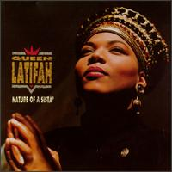

*"Oh now attitude, why even bother  
I can't change your mind  
You can't change my color  
Free your mind and the rest will follow"*

**Funky Divas, "Free Your Mind"**

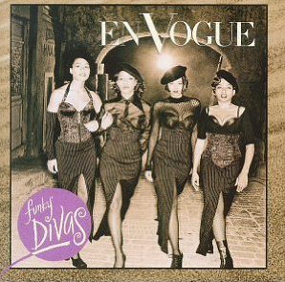

To find more inspiring songs, go to EdChange (http://www.edchange.org/multicultural/arts/race_songs.html)

**WYSIWYG** means *What You See Is What You Get*. When something on a computer is WYSIWIG, it means that what you see on the computer screen is what you would see if you printed it or displayed it somewhere else.

Website Design Requirements

* Does your website have a theme?
* Does your theme include a need for an chat or IM feature?
* Does your website have at least 4 pages?
* Do your web pages link (connect) to each other?
* Does your website have at least 2 links to outside websites? Do the outside websites have to do with your theme?
* Do users know how to use your website or how to get around (navigate)
* Does one page have information about you (the engineer/ creator/ designer) of the website?
* Does your website have 2 images that have to do with your theme?
* Do your pages have a similar look? Can users tell that all pages are part of the theme?