# The ICT4me Curriculum

## About ICT4me

ICT4me is an after school and summer curriculum for middle school youth to develop ICT fluency, interest in mathematics, and knowledge of information, communication, and technology (ICT) careers. This problem-based curriculum capitalizes on youth interest in design and communication technologies. ICT4me provides structured interactions with ICT professionals, including having youth participate in engineering design and development teams. ICT4me's promotes a train-the-trainer approach to building capacity in informal ICT learning.

**Build IT vs. ICT4me**

ICT4me is a derivative of the Build IT curriculum co-developed between SRI International and Girls Inc. of Alameda County. Questions about the Girls Inc. implementation of Build IT can be directed to them at <http://www.girlsinc-alameda.org/about/contact>.

SRI is no longer supporting the development of ICT4me, so the curriculum materials are offered as is.

## Copyright

Copyright © 2016 by SRI International. All rights reserved.

## Attribution

This material is based upon work supported by the National Science Foundation under Grant Nos. 1339181, 1232461, and 0524762. Any opinions, findings, and conclusions or recommendations expressed in this material are those of the author(s) and do not necessarily reflect the views of the National Science Foundation.

## Electronic Versions of Materials

Electronic versions of all materials in this unit are available for download from the website at <http://ict4me.sri.com/>.

## Contact Information

Please contact the SRI International Inquiry line for questions about ICT4me.

<https://www.sri.com/contact/form>



Unit 2

Activity Pages

Table of Contents

Activity Pages Week 1 3

Venn Diagram Cards 4

Elements of a Web Page 5

Facilitator Page 7

Web Page Design (Electronic Activity) 8

Activity Pages Week 2 9

How the Internet Works (Electronic Activity) 10

Understanding URLs (Electronic Activity) 11

Facilitator Page: Answer Key 12

Activity Pages Week 3 13

Comparison Chart of Communication Tools 14

Example Station Setup 15

Activity Pages Week 4 16

Gatherer Role Sheet 17

Interviewer Role Sheet 18

Photographer Role Sheet 19

Sketch Artist Role Sheet 20

IT Professional Snapshot Template 21

Activity Pages Week 5 22

Cyberclub Design Requirements Checklist 23

Designing Your Cyberclub 24

Cyberclub Sketch 25

Ideas for Possible Clubs 26

Activity Pages Week 6 27

BART Subway System Map 28

Washington, DC, Subway System Map 29

Airplane Flight Routes 30

Nina’s Travels 31

Pilot’s Travels 32

Cyberclub Connections (1) 33

Cyberclub Connections (2) 34

Graph Theory: A Tool for Software Designers and Engineers 35

Original Use of Graph Theory 36

Math in School: The Important Facts 37

Activity Pages Week 7 39

Engaging Members 40

Hosting A Gathering 42

Cyberclub Design Requirements Checklist 43

Activity Pages Week 8 44

Cyberclub Design Requirements Checklist 45

Activity Pages Week 9 46

Footprint Silhouette Example 47

Example Blogs 48

Setting Up a Blog 49

The Design Process poster 50

Designing Your Blog 51

Possible Themes 52

Blog Design Requirements 53

Activity Pages Week 10 55

Algorithmic Thinking Handout 1 56

Algorithmic Thinking Handout 2 57

Algorithmic Thinking Handout 3 58

Algorithmic Thinking Handout 4 59

How to Do the Math Answer Key 60

Activity Pages Week 11 61

Blog Design Requirements Checklist 62

Activity Pages Week 12 64

Gatherer Role Sheet 65

Interviewer Role Sheet 66

Photographer Role Sheet 67

Sketch Artist Role Sheet 68

IT Professional Snapshot Template 69

Activity Pages Week 13 70

Starter List of Blog/Group Activities 71

Forms and Functions Game Sheet Instructions & Key 72

Facilitator Page: Rubric for Matching Form to Function 73

Activity Pages Week 1

Venn Diagram Cards 4

Elements of a Web Page 5

Facilitator Page 7

Web Page Design (Electronic Activity) 8

Venn Diagram Cards

There should be two sets of these cards, one for each team playing the “Communiputing Game”. Cards should be color coded for each team (i.e. Team 1 = Green, Team 2 = Violet).

Make 8 FTF cards. Each card should have one of the following phrases on it:

* whisper to a friend
* tell 4 people in a room that you are home
* make an announcement at an assembly of 100 people
* talk to your mom
* everyone talking at a party
* post a note on a bulletin board
* pass a note to a friend
* write a book

Make 8 Technology cards. Each card should have one of the following phrases on it:

* send email to 3 people
* send email to 1 person
* chat with 3 people
* post to your blog that 20 people read
* use an online group to work on an issue with10 people
* connect several blogs to address an issue
* join a social network
* use a discussion board for a class project

8 Blank cards. On these cards, girls will write their unique communication ideas.

* 4 cards with the letters “FTF” in the corner
* 4 cards with the word “Technology” in the corner.

Elements of a Web Page

[**http://www.engineergirl.org**](http://www.engineergirl.org)

Label the elements of a web page, using the boxes of terms below:

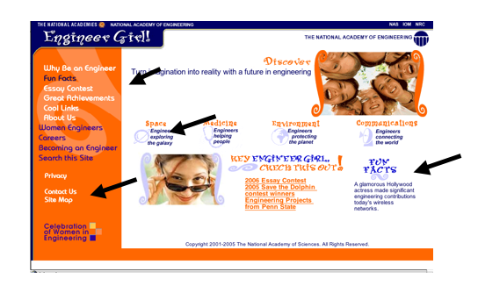

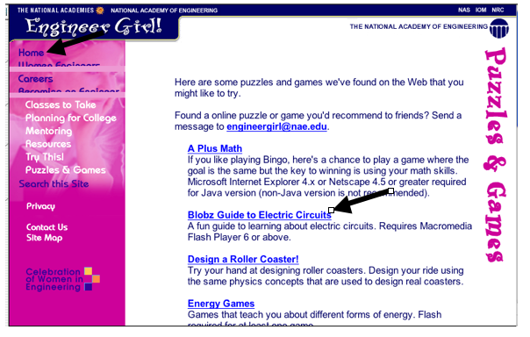

is often on the left or at the top of the page. Navigation helps you find your way around a website.

Navigation

main page of the site, located at the domain name level (e.g. <http://www.engineergirl.org>)

link to other pages on the website or to other websites

web pages generally have information to share. Some of this information is updated on a regular basis (i.e. news)

way to contact the developer of the site via email address or other means

facilitate communication among visitors to the site. The tools may also enable visitors to talk with developers. Tools may include discussion boards, polls, or chat.

Hyperlink

Homepage

News & Information

Contact Information

Communication Tools

Facilitator Page

Answer Key for Elements of a Web Page



Contact Information

Navigation

Communication Tools

News & Information



Homepage

Hyperlink

Web Page Design (Electronic Activity)

Choose two of the following websites to explore:

1. Discovery Kids at http://kids.discovery.com/
2. National Geographic Kids at <http://www.nationalgeographic.com/kids/>
3. Your favorite site—choose your own!

**Website 1: Name and URL of the website _______________________________**

* Where is the navigation on this site?
* What is the main idea of this site?
* Where is the contact information?
* Click on one hyperlink. Where does it take you?
* Is there a section for news and information? Click on it. What do you see?
* What’s one way that users of this site could communicate with each other?

**Website 2: Name and URL of the website _______________________________**

* Where is the navigation on this site?
* What is the main idea of this site?
* Where is the contact information?
* Click on one hyperlink. Where does it take you?
* Is there a section for news and information? Click on it.
* What’s one way that users of this site could communicate with each other?

Activity Pages Week 2

How the Internet Works (Electronic Activity) 10

Understanding URLs (Electronic Activity) 11

Facilitator Page: Answer Key 12

How the Internet Works (Electronic Activity)

**Go to the links and check out how the Internet works!**

**Learn the Net**

Animations and graphics of how the Internet works

* Connecting to the Internet

<http://www.learnthenet.com/learn-the-basics/>

* How Information Travels on the Internet

<http://www.learnthenet.com/learn-the-web/>

* How e-mail works

<http://www.learnthenet.com/learn-email/>

<http://www.wydea.com/topic?id=email>

* Instant Messaging

<http://www.learnthenet.com/how-to/instant-message/index.php>

**Intel’s *The Journey Inside***

* How Information Travels on the Internet

<http://educate.intel.com/en/TheJourneyInside/ExploreTheCurriculum/EC_TheInternet/ILesson3/>

* Web Address: What is a URL?

<http://educate.intel.com/en/TheJourneyInside/ExploreTheCurriculum/EC_TheInternet/ILesson2/>

* E-mail Address

<http://www.learnthenet.com/email-at-a-glance/addresses/index.php>

**Wikipedia’s Text description of Instant Messaging**

* Instant Messaging and IM address

<http://en.wikipedia.org/wiki/Instant_messaging>

Understanding URLs (Electronic Activity)

**Look at the following web addresses (URLs). Check out the websites. What do these addresses have in common? What is different?**

Girls Inc.

<http://www.girlsinc.org/>

Engineer Girl

<http://www.engineergirl.org/>

San Francisco State University

<http://www.sfsu.edu/>

Oakland Unified School District

<http://www.ousd.k12.ca.us>

Google España

<http://www.google.es/>

Universidad Regiomontana

<http://www.ur.mx/>

White House Education

<http://www.whitehouse.gov/issues/education>

First Gov for Kids: Careers

<http://www.kids.gov/k_careers.htm>

National Geographic Kids

<http://kids.nationalgeographic.com/>

National Geographic

<http://www.nationalgeographic.com/>

Scholastic News

<http://magazines.scholastic.com/>

Facilitator Page: Answer Key

E-mail and Website Paths on the Internet

Client A’s Computer

Router

Client B’s Computer

ISP

E-mail Server

Web Server

ISP

E-mail Server

Web Server

Router

Router



Web Server

Web Server



**Key**

***E-mail path***

E-mail  and image  start on client computer.

Requests occur when client A asks her e-mail server to send e-mail and when client B asks her e-mail server for her e-mail messages.

***Web path***

Image starts on server. Request is when Client A asks for image  from web server.

The requests, e-mail, and images are not part of the network infrastructure.

Shown here are just the main network lines needed for the e-mail message and web requests. More connections and more computers (i.e., clients, servers, and routers) could be made.

Activity Pages Week 3

Comparison Chart of Communication Tools 14

Example Station Setup 15

Comparison Chart of Communication Tools

Complete a row for each communication tool. The last column allows you to rate the overall fit with your communication needs (i.e. your scenario). Rate the tool by 1 = not a good fit; 2 = it fits enough to do some things, 3 = fairly good fit, 4 = good fit, to 5 = the best fit.

|  |  |  |  |  |  |
| --- | --- | --- | --- | --- | --- |
| **Tool Used**  Discussion board, chat, blog, status messages, etc. | **How do you communicate using this tool?** Synchronous (online at the same time) or Asynchronous (not at the same time) | **Advantages**  Try to think of at least 3 | **Disadvantages**  Try to think of at least 3. | **Overall fit**  **with your communication needs** | **R**  **A**  **T**  **E** |
|  |  |  |  |  | **1**  **2**  **3**  **4**  **5** |
|  |  |  |  |  | **1**  **2**  **3**  **4**  **5** |
|  |  |  |  |  | **1**  **2**  **3**  **4**  **5** |
|  |  |  |  |  | **1**  **2**  **3**  **4**  **5** |

Example Station Setup

Board

Station 4:

Status Message

Sample Room Layout

The layout can vary depending on the number of girls in your class.

You can have more than 1 type of each station if you have enough computers.

Projects

Activity Pages Week 4

Gatherer Role Sheet 17

Interviewer Role Sheet 18

Photographer Role Sheet 19

Sketch Artist Role Sheet 20

IT Professional Snapshot Template 21

Gatherer Role Sheet

***Your role is to work with your partner to collect “field data” from the place you are visiting tomorrow on your field trip and fill your bag! Open your eyes wider than they have ever been before! Look where others may not see everything when you are on site, see yourself as a true investigator that has just arrived on the scene!***

**Things to consider for your investigation and “Gatherer Bag” of goodies:**

1. Brochures
2. Business cards
3. Leaflets
4. One pagers for visitors
5. Samples, giveaways, or goodies!
6. Logo of the business or site
7. A leaf, small rock, some small natural memento from the walk up to or around the site
8. Write down any quotes, clues, key phrases or mottos that the business says a lot or seem to work by and believe in like Girls Inc, being “Strong, Smart & Bold”
9. Help direct your “Photographer” partners to scenes, activities, objects and people to consider photographing and filming.





Interviewer Role Sheet

***Your role is to work with your partner to collect information by interviewing the “IT Professionals” hosting at your field trip with the suggested questions below. You don’t have to use all of the questions. Practice with your partner asking questions before the trip to get comfortable with introducing yourself, eye contact and thanking the person in which you are asking questions. Have fun with it! This is your chance to become a journalist and reporter! Imagine yourself in the bright lights on location on the evening news!***

**Questions to consider asking as an interviewer with your clipboard. Plan which questions you will ask and which ones your partner will ask or one partner asks while another writes and uses the digital recorder:**

1. What is your official job title?
2. How do you see women having an impact in this field?
3. How would you describe what you do here?
4. What do you like about the most about your job?
5. 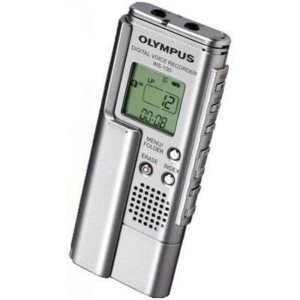What do you like the least about your job?
6. Please describe your life outside of work.
7. What hobbies and interests did you have growing up related to this job? (current and during middle school, high school, college)
8. What is your educational background?
9. Please describe your career path and what lead you here today.

**These are questions to ask of your fellow Build IT girls that are on this trip, and for you and your partner to answer as well:**

1. What is something new you learned today?
2. What did you learn today that was different than what you before coming on this trip, a myth that was exposed today?
3. What do you want to know more about?
4. What should people who did not go on this field trip know about?

Photographer Role Sheet

***Your role is to work with your partner to capture pictures of your field trip experience. This is your shot of being a real camerawoman on the scene! You get to be the eyes of the day and shoot with your perspective and find images maybe others will not see. Consider the background, is what you are seeing through the lens tell the story of what you want to share? You have a very important role. Please focus on aspects of the organization you are visiting and the professionals you are meeting on the trip—and not taking extra photos of girls posing that will wear down the batteries.***

**Plan with your partner who will take pictures of certain things so you don’t do double work and have too many photos of the same things. What to look for:**

1. Buildings
2. Equipment/Tools of the trade
3. Posters, Charts, Equations, etc.
4. The location/site
5. IT Professionals who say it’s ok to take their pictures
6. People at work if they say it’s ok
7. Other Build IT girls learning, trying out tools, talking about what they like on trip, etc





Sketch Artist Role Sheet

***Your role is to work with your partner to sketch cool things you are witnessing on your field trip! This is your start as a “live artist” just like the courtroom sketch artists that show the scene because cameras are not allowed! You get to capture in small sketches what others may not see! Remember sketches do not always have to be pictures it can be words on a board, one detailed part of a machine, a sign posted on site, someone’s name tag, someone’s hand using equipment…”stretch” or should I say “sketch” your mind!***

**Plan with your partner who will sketch images of certain things so you don’t do double work and have not enough original work of the experience. What to look for photos:**

1. Buildings
2. Equipment/Tools of the trade
3. Posters, Charts, Equations, etc.
4. The location/site
5. Processes that you see people doing to get their work done. Can you make the process a flow chart?
6. Remember to be creative! A pageful of 5-10 small sketches that you can color in with colored pencils/markers at lunch time, on the bus or finish during the next Build IT session is perfect planning!

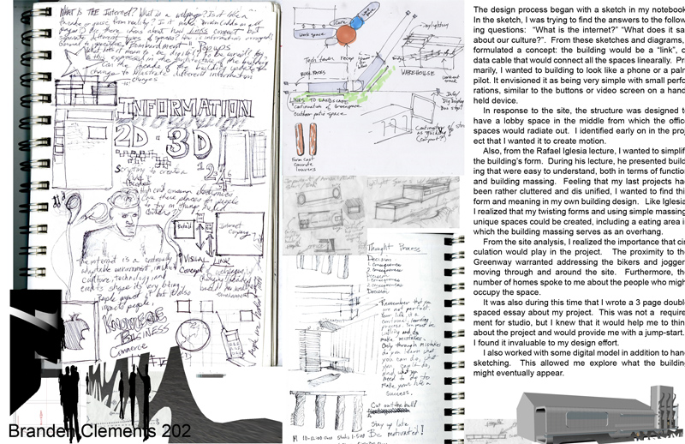



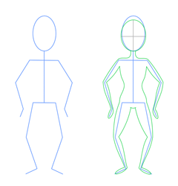IT Professional Snapshot Template

Other pictures and sketches that depict where they work and what they do

**Name**

Job title

What they do

URL for their bio

**Why is their job important?**

**About [Name of IT Professional]**

What they like about their job

Their life outside of work

Their hobbies and interests **What do they create?**

Describe product or service

Provide a URLs for their company & products

**Education & Experience**

Their educational background

Their career path

Activity Pages Week 5

Cyberclub Design Requirements Checklist 23

Designing Your Cyberclub 24

Cyberclub Sketch 25

Ideas for Possible Clubs 26

Cyberclub Design Requirements Checklist

Follow these requirements to complete your Cyberclub:

1. Develop **a clear goal:** Think of what the point of your club is and what you want your club to accomplish. That is your goal. Write it out in one or two sentences. (Use the Design Your Cyberclub handout to help you develop your goal.)
2. Your Cyberclub needs to have the following:
   * Create a **name** for your group’s Cyberclub
   * Write down the URL for your Cyberclub: ________________________________________________
   * **Edit** your **Information** to encourage people to become club members
   * **1st topic** on discussion forum related to Cyberclub’s goal
   * **2nd topic** on discussion forum related to Cyberclub’s goal
   * **Write a Text Box** message
   * **1st link** to a place on web related to Cyberclub’s goal (links can be on the discussion forum)
   * **2nd link** to a place on web related to Cyberclub’s goal
   * **3rd link** to a place on web related to Cyberclub’s goal
   * **1st image** related to Cyberclub’s goal (this can be in the discussion forum)
   * **2nd image** related to Cyberclub’s goal
3. From hosting a gathering:
   * **1st activity** for club members to help accomplish Cyberclub’s goal. Include one communication tool in this activity
   * **2nd activity** for club members to help accomplish Cyberclub’s goal. Include a different communication tool in this activity from that in the 1st activity.
4. Make your Cyberclub interesting! You want to get people to visit your Cyberclub and to participate in the activities.

Designing Your Cyberclub

Group name

1. **Define the problem**

a) In one sentence, what is the main point of your club? (Use this as your Tagline)

1. **Brainstorm**

a) Why will people want to join your club?

b) How will club members work together using your Cyberclub? (Think of something club members can share that is related to the topic of your group.)

c) What is your club’s name?

Cyberclub Sketch

Now use your design notebook to sketch your ideas and make some notes about what you want to include in your Cyberclub. Look at the Ning features again while you sketch and write notes. Here is an example of how to sketch your Main Page.

The title of your Cyberclub goes

in here

Sketch your Main page like this:

The navigation bar includes features that goes here

Communication tools go here. List some of the tools you will use (Chat, Blog, Photos, Events, Notes)

Name on

Ideas for Possible Clubs

If you have difficulty coming up with a mission for your club, here are some suggestions, you can reference the links to help get a few ideas. But come up with your own club goals if possible, avoid choosing a mission that you have no interest in creating a club for. Make sure the club theme is relevant to girls’ lives.

Here are a few theme ideas to help develop clubs:

**GGG**. Girls Gone Geek. A site for Women and Girls who love technology and want to share latest information in the world of technology.

* **Kids Care Club**. Kids Care Club seeks to inspire, equip, and mobilize middle school and high school youth to take action that changes the world and themselves through service.
* **DID**. Dance into Dollars is a club that organizes dance contests to raise money for community projects.
* **SOY**. Soccer for Oakland Youth is a club for youth that live in Oakland and play soccer. Schedules and locations of games, team scores, strategies, and pick-up games are organized and discussed.
* **Musical Youth**. Musical Youth is a club to support youth interested in developing their musical talent into a music career.
* **Hockey Heroes.** The ultimate fan site for people who love hockey.

Activity Pages Week 6

BART Subway System Map 28

Washington, DC, Subway System Map 29

Airplane Flight Routes 30

Nina’s Travels 31

Pilot’s Travels 32

Cyberclub Connections (1) 33

Cyberclub Connections (2) 34

Graph Theory: A Tool for Software Designers and Engineers 35

Original Use of Graph Theory 36

Math in School: The Important Facts 37

BART Subway System Map

# 

Washington, DC, Subway System Map

# subway

Airplane Flight Routes

# 

# 

# 

Nina’s Travels

Nina was planning to visit several of her relatives over break. She was flying on an airline that requires her to change planes in New York and Denver so she can get to the other cities. She had to get to Milwaukee to see her Aunt Millie and to Dallas to see her Uncle Mweusi and to Miami to see her Uncle Luis. Here's a picture of the flight paths for this airline:

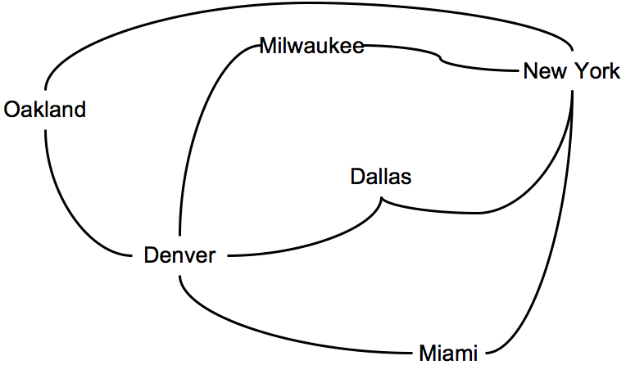

Can Nina fly on each flight path exactly once and end up back in her own city of Oakland? Can she do it if she skips the trip to Miami?

Pilot’s Travels

Ms. Willingham is a charter pilot. She has a small plane for special services. Right now, she has to deliver gifts for the children’s hospitals at several cities around the country. She would like to take the shortest route and visit each city only once before returning home. Can you help her? Trace a route through all the green dots (each dot represents one of the cities on Ms. Willingham’s routes).



Compare your answers with those of others to see how you did. Did you find the shortest route? Did anyone else?

Cyberclub Connections (1)

*Explore the connections among the members in a Cyberclub you have created using graph theory.*

1. Think about all of the members in a Cyberclub and the passageways between them. This Cyberclub has many members and each member has at least three friends that they are linked with. Every member may or may not have passageways to you. Make a diagram to show the members in a Cyberclub and the passageways that they have to each other.

Cyberclub Connections (2)

Congratulations! You just made a graph. It’s just nodes and edges. Your Cyberclub member circles are the nodes. Your arrows showing passageways are the edges. We care about direction, so you have made a directed graph.

*Explore the connections among the members in a Cyberclub using graph theory.*

Using links between friends, can you start from your member profile and visit every other member exactly once (no repeats), landing back in your own member profile? Use your diagram to help you. (Hint: Remember Ms. Willingham’s trip?)

Test your idea in the online collaboration space. Draw your route in colored pencil. Then use your map to move from the last member you ended with to your own member profile.

If you cannot find a way to visit each Cyberclub member only once, add passageways to your diagram so that you can. Get Cyberclub members to add the passageways you drew in and then test your route.

1. Show the route in colored pencil on your diagram.

Graph Theory:   
A Tool for Software Designers and Engineers

**Read and discuss:**

Software engineers and designers created the whole Ning structure. They created a space that can be represented with the nodes and links we used in this session. For example, the connections between rooms and tools can get complicated and messy. Mathematical tools help organize the connections so we can analyze them and then write algorithms for dealing with them.

The previous activities were based on a branch of mathematics called graph theory. These are **not** the graphs we see in algebra class. These graphs are very simple but powerful mathematical tools. We used them to analyze our Cyberclub communication paths by hand*. But think about the ideas you use; those can be written into a computer program that can handle many, many Cyberclubs at a time.*

Graph theory is usually taught in second or third year college math courses, but you can understand and use them today. You can probably use them again, whenever you want to show how things are related. For example, family trees are a kind of graph. You can use graphs to show relationships and paths, like the best route to take on a walk or using public transportation.

Original Use of Graph Theory

“A problem was posed to me about an island in the city of Königsberg, surrounded by a river spanned by seven bridges, and I was asked whether someone could traverse the separate bridges in a connected walk in such a way that each bridge is crossed only once... This question is so banal, but seemed to be worthy of attention in that geometry, nor algebra, nor even the art of counting was sufficient to solve it. In view of this, it occurred to me to wonder whether it belonged to the geometry of position that Leibniz had once so much longed for. And so, after some deliberation, I obtained a simple, yet completely established, rule with whose help one can immediately decided for all examples of this kind, with any number of bridges in any arrangement whether such a roundtrip is possible or not…”

*Leonhard Euler to Giovanni Marinoni, March 13, 1736*

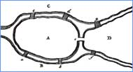

The Graph Theory Route 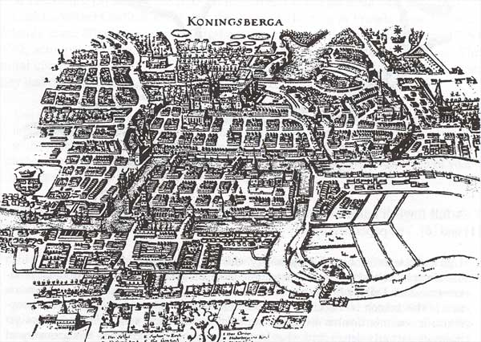

Math in School: The Important Facts

Exercise your rights as a math student.

*You have a right to understand the math taught in class*. Find respectful ways to exercise that right. It’s better to ask specific questions than to just say, “I don’t understand.”

*Use these sentence starters:*

I don’t understand how to…

I don’t understand why….

This is where I get stuck.

Could you say that again, in different words? I didn’t quite get it.

*For example:*

I don’t understand how to factor a polynomial. Here’s what I have done so far.

I don’t understand why you cross multiply to find the answer. Can you explain it to me, again, in different words?

*It’s a good thing to get extra help.*

Homework time at your afterschool program is a great time to ask other youth who understand the math or an afterschool staff member for help.

Math teachers are often willing to spend extra time with you. Go to talk to your teacher after school.

Parents can help too! Sometimes it’s a matter of finding the person who is able to explain the math well so that you understand.

Exchange phone numbers with a classmate so you can check in if you are stuck.

*You have a right to be placed in the math class* that will help you achieve your goals. If you are not in Algebra in 8th grade, you or your parents can question that. If it turns out you are ready for Algebra, go for it!

You need to take math now and in high school.

To graduate from high school in most states you must:

*For example, in California:*

Take two years of math, including algebra.

Pass the High School Exit Exam. The math includes algebra.

In ____________________:

Take _____________________________________________________________________ ______________________________________________________________________________________________________________________________________________________________________________________________________________________________

To aim higher for college

For example, the University of California admission requirements are:

Mathematics – Three YEARS REQUIRED, Four YEARS RECOMMENDED

Three years of college-preparatory mathematics that include the topics covered in elementary and advanced algebra and two- and three-dimensional geometry.

That’s what you need for University of California admission. If you aim high, you’ll look very good to colleges.

You can take some of these classes in middle school, and that counts! That’s why it’s good to try for Algebra in 8th grade.

To prepare for most jobs, in high-tech or not

You need high-level math for jobs that are rewarding and allow you to be creative. Calculating is NOT enough. Companies need problem solvers.

Math is exciting and everywhere!

When you do these things, you are doing math:

Jeans are on sale for 40% off. You have a rough idea how much you’ll pay for the pair you like. You just estimated using percentage.

You figure out the best combination of buses to take to your friend’s house. You just did problem solving for optimization.

There’s more to math than just finishing 15 problems from the book each night. Try fun problems from *Figure This!*,a website for families http://www.figurethis.org/.

Activity Pages Week 7

Engaging Members Prompts 40

Hosting A Gathering 42

Cyberclub Design Requirements Checklist 43

Engaging Members Prompts

Group 1: Communicating with Members

***Expert Statements:***

The people who join your club are not likely to be just anyone. Certain kinds of people are more likely to join your club than others. Knowing what your club is about is the first important step to getting members to join.

You need to make it easy for people to understand the purpose of your club. Make it easy by providing good information to people in the main areas of your club page, and places that members would go.

*Website:* http://teensforplanetearth.ning.com (T4PE is a social networking site for teens who want to protect the planet. Teens can choose a project, connect with others, and make a difference)

***Questions:***

* What kinds of information do you see on this site?
* What kinds of communication tools are used to inform others of what’s going on in the site?

Group 2: Engaging Users

***Expert Statements:***

People like to go to websites where they can add their own content (such as pictures, video, music, or text). They also like to access good content that is useful to them and that are updated regularly.

People often go to websites for advice or suggestions, to find out where to buy certain things, or to plan events for a group that already exists.

*Website:* <http://www.discoverygirls.com/> (This site has a lot of polls, discussion boards, and other communication tools that allow youth to create their own content as well as enjoy the content provided by the magazine.)

***Question:***

* What do you think is exciting for youth to do on this site?
* Why would it be exciting?

Engaging Members continued

Group 3: Keeping Interests High

***Expert Statements:***

People return to websites that have a clear purpose, and that, when they get there, don’t surprise them with the topic on the website.

People return to sites where they can express their points of view and meet others who share their interests.

*Website:* <http://members.agirlsworld.com/index.html> (This site is the first “girls only” E-pal club, it is also part of a larger E-magazine called “A Girls World,” an online magazine written and edited by girls and teens from around the world.)

***Question:***

* What would make youth come to this site more than once?
* What makes this site feel safe for youth to share their thoughts?

Hosting A Gathering

Group name

**Define the goals**

What is the point of your gathering?

**Activity 1:**

What will club members do? (Are they collecting items, blogging on topics, or making discussion topics?)

What is one communication tool they will use for activity 1?

What instructions will you give for activity 1, where will you post it?

**Activity 2:**

What will club members do after activity 1? (Are they collecting items, blogging on topics, or making discussion topics?)

What is one communication tool they will use for activity 2?

What instructions will you give for activity 2, where will you post it?

Cyberclub Design Requirements Checklist

Follow these requirements to complete your Cyberclub:

1. Develop **a clear goal:** Think of what the point of your club is and what you want your club to accomplish. That is your goal. Write it out in one or two sentences. (Use the Design Your Cyberclub handout to help you develop your goal.)
2. Your Cyberclub needs to have the following:
   * Create a **name** for your group’s Cyberclub
   * Write down the URL for your Cyberclub: ________________________________________________
   * **Edit** your **Information** to encourage people to become club members
   * **1st topic** on discussion forum related to Cyberclub’s goal
   * **2nd topic** on discussion forum related to Cyberclub’s goal
   * **Write a Text Box** message
   * **1st link** to a place on web related to Cyberclub’s goal (links can be on the discussion forum)
   * **2nd link** to a place on web related to Cyberclub’s goal
   * **3rd link** to a place on web related to Cyberclub’s goal
   * **1st image** related to Cyberclub’s goal (this can be in the discussion forum)
   * **2nd image** related to Cyberclub’s goal
3. From hosting a gathering:
   * **1st activity** for club members to help accomplish Cyberclub’s goal. Include one communication tool in this activity
   * **2nd activity** for club members to help accomplish Cyberclub’s goal. Include a different communication tool in this activity from that in the 1st activity.
4. Make your Cyberclub interesting! You want to get people to visit your Cyberclub and to participate in the activities.

Activity Pages Week 8

Cyberclub Design Requirements Checklist 45

Cyberclub Design Requirements Checklist

Follow these requirements to complete your Cyberclub:

1. Develop **a clear goal:** Think of what the point of your club is and what you want your club to accomplish. That is your goal. Write it out in one or two sentences. (Use the Design Your Cyberclub handout to help you develop your goal.)
2. Your Cyberclub needs to have the following:
   * Create a **name** for your group’s Cyberclub
   * Write down the URL for your Cyberclub: ________________________________________________
   * **Edit** your **Information** to encourage people to become club members
   * **1st topic** on discussion forum related to Cyberclub’s goal
   * **2nd topic** on discussion forum related to Cyberclub’s goal
   * **Write a Text Box** message
   * **1st link** to a place on web related to Cyberclub’s goal (links can be on the discussion forum)
   * **2nd link** to a place on web related to Cyberclub’s goal
   * **3rd link** to a place on web related to Cyberclub’s goal
   * **1st image** related to Cyberclub’s goal (this can be in the discussion forum)
   * **2nd image** related to Cyberclub’s goal
3. From hosting a gathering:
   * **1st activity** for club members to help accomplish Cyberclub’s goal. Include one communication tool in this activity
   * **2nd activity** for club members to help accomplish Cyberclub’s goal. Include a different communication tool in this activity from that in the 1st activity.
4. Make your Cyberclub interesting! You want to get people to visit your Cyberclub and to participate in the activities.

Activity Pages Week 9

Footprint Silhouette Example 47

Example Blogs 48

Setting Up a Blog Outside of Ning 49

The Design Process 50

Designing Your Blog 51

Possible Themes 52

Blog Design Requirements 53

Think.com Design Checklist 54

Footprint Silhouette Example



Example Blogs

Blogs of Note lists a variety of popular blogs: <http://blogsofnote.blogspot.com>

Personal Interests

Mehan shares her cooking treats and recipes too

<http://mehanskitchen.blogspot.com/>

Mandy is a puppy raiser for Guide Dogs with lots of experience

http://www.doyourbusiness.org/

Travel

Buster’s travels with his dad:

<http://pbskids.org/buster/blog/index.html>

A college student travels the world and share her found wisdom:

<http://jessicahdrw.blogspot.com/>

Professional

Allegra Martin, an aspiring choral conductor:

<http://currentconductor.blogspot.com/>

Slinkachu, a street artist, shares his perspective:

http://little-people.blogspot.com/

Setting Up a Blog

Note: Update this page for whichever blog tool you plan to use. The directions below many need to change depending on the blog tool.

The page may look something like this one. Fill in this sheet first and show it to your youth before entering this information online.

**Step 1: Create your blog**

|  |  |  |
| --- | --- | --- |
| Choose a username |  | You’ll use this to sign in for future visits. |
| Enter a password |  | Must be at least  6 characters long. |
| Retype password |  | Enter it again just to be sure. |
| Display name |  | The name used to sign your blog posts. |
| E-mail address |  | We will never share your address with third parties without your permission. |
| Acceptance of Terms | * I accept the Terms of Service | Indicate that you have read and understand Blogger’s Terms of Service. |

Click CONTINUE.

**Step 2: Name your blog**

|  |  |
| --- | --- |
| Blog title |  |
| Blog address | http://________________.blogger.com |
| Word Verification | Type the letters that appear on the screen here. |

Click CONTINUE.

**STOP HERE: Step 3 must be done online.**

**Step 3: Choose a template**

Click on “preview template” to see a larger version.

Click on the picture of the template to choose it (it will get a darker outline when you do this).

Click CONTINUE.

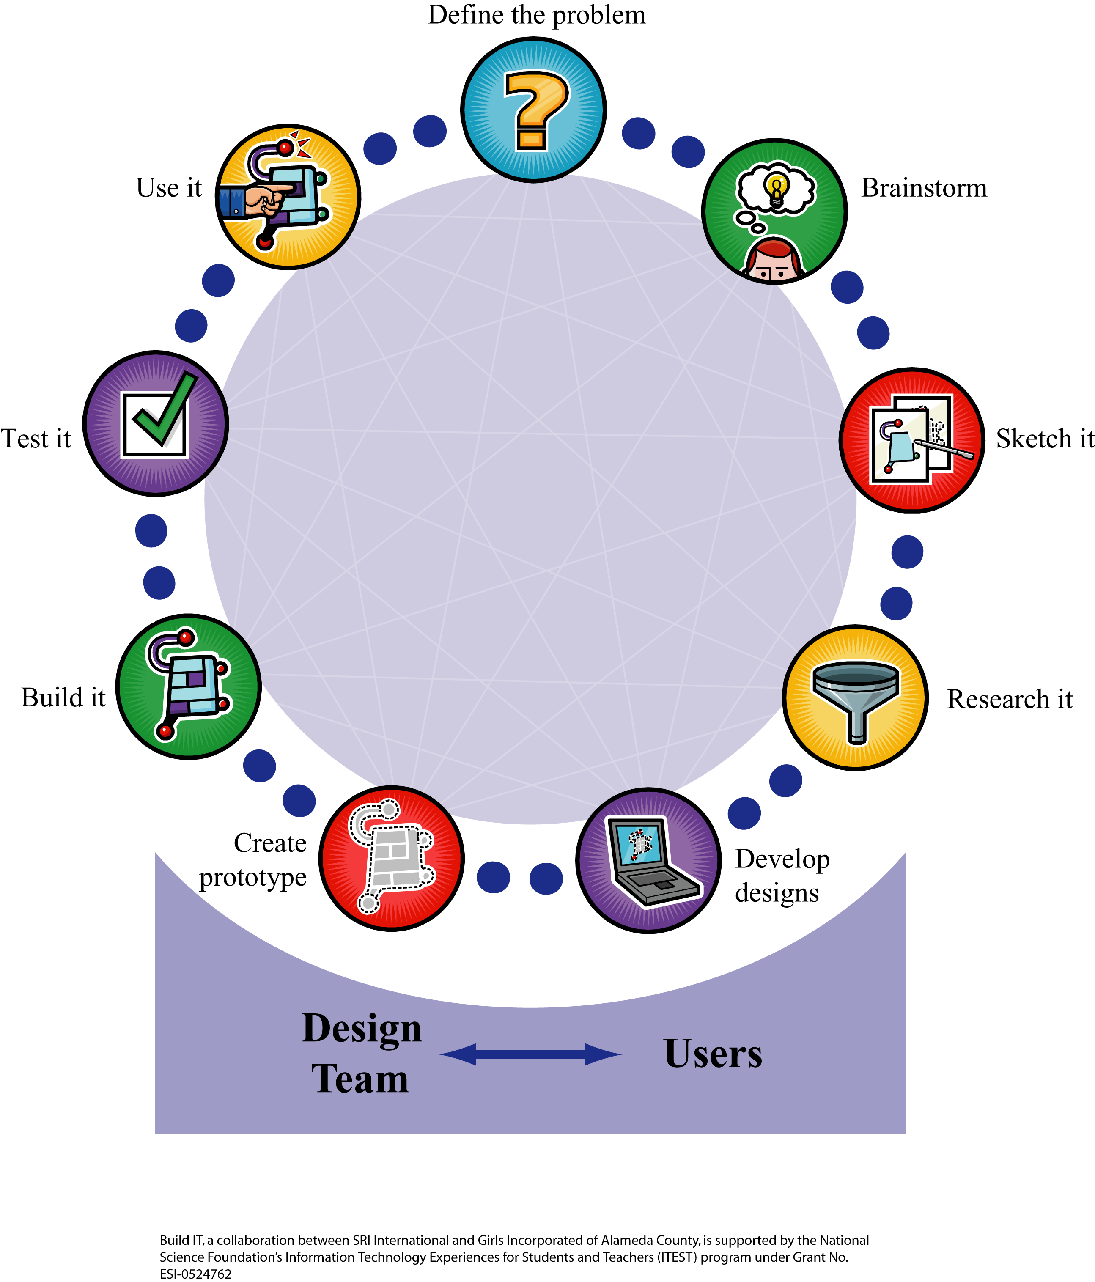The Design Process

Designing Your Blog

Name

**Define the problem:**

Who is your audience?

What are they looking for when they come to your blog?

What do you want to say to them?

**Brainstorm:**

What theme do you think people reading your blog will like?

**Sketch:**

Now use your Design Notebook to sketch your ideas and make some notes about what you want to include in your blog.

Possible Themes

If youth have difficulty coming up with a theme, here are some suggestions. Let the youth come up with their own themes if possible since they will have seen others’ blogs and may have their own ideas. Avoid having youth just choose a theme that they have no interest in creating a blog for.

Here are a few theme ideas to help girls develop their blogs. Whichever theme youth choose, they should have at least three separate entries:

* **Our Journal** — write about your life over time.
* **Our Travel Journal** — write about a trip you took. Better yet, write as you travel.
* **Our Community or School** — write about events that are happening in your school or community.
* **Our World** — choose an issue that affects all of us that you want to research and write about. Be sure to include at least three entries.
* **Our** **[insert something you want to write about over several days].**

Blog Design Requirements

1. □ Develop **a clear** **theme**. Think of a theme for your blog that requires a journal-like feature. Use the Designing your Blog handout to help you develop your theme.
2. □ Write at least **three entries**. Your blog should have multiple entries about different days or experiences.
3. □ Include at least **four links** to external sources. These sources should be related to the theme of your site. They can be links to other girls’ blogs.
4. □ Include at least **four images**. Your blog must include at least four images that relate to your theme.
5. □ Make your blog **easy to navigate**. Users of your blog must be able to quickly understand how to navigate it. They must understand where they are on your blog.
6. □ Develop a **common look and feel** for all pages. All the pages (if you have multiple pages) must have a common look and feel. Users of your blog should be able to tell that all the pages belong together.
7. □ Have a page or entry about you so that readers know who the author of the blog is
8. □ Add an interesting and relevant tool, such as voting or status message, to your blog that enables further sharing about your theme.

Activity Pages Week 10

Algorithmic Thinking Handout 1 56

Algorithmic Thinking Handout 2 57

Algorithmic Thinking Handout 3 58

Algorithmic Thinking Handout 4 59

How to Do the Math Answer Key 60

Algorithmic Thinking Activity page 1

**Will __________________ Come to Town?**

**__________________**(fill in artist’s name here and above) has agreed to give a free surprise concert in the local park in one week. The school music committee is in charge of getting the word out. You are on the committee.

We have some problems:

* + 1. It’s Spring Break, and nobody knows about the concert.
    2. We have to sell at least 60 tickets from a special ticketing website before the concert in the next week or the concert will be cancelled.
    3. You are on the school trip exploring Mayan ruins in Mexico. You can’t use your cell phone from Mexico and it’s too late to advertise in the newspaper or on radio.

***BUT…***

*We know a lot of students are able to access a special website and they would buy tickets if they knew about the concert.*

What is required to get _____ to do the spring concert? Write the answer in your own words.

Algorithmic Thinking Activity page 2

**Your Great Idea**

You and the school music committee come up with a great idea: Spread the word by using blogs. You know of two students who write popular blogs. Here’s information about them.

*Polly’s Blog (commercial posts – $10)*

Polly is new to the school—she doesn’t know many people yet. But for those who have gotten to know her, she seems like she’d be a good friend.

Only 3 students read Polly’s blog and do what Polly says.

Each of these 3 readers has two best friends. They also take Polly’s advice.

Of course, Polly also follows her own advice.

*If you pay Polly $10 she will do a “commercial post” telling people to go to*

*the concert.*

*Arcela’s Blog (commercial posts - $50)*

Arcela is a senior and better known than Polly.

Ten students read her blog every day.

Each of these 10 readers spreads the word to their 5 friends.

Of course, Arcela also follows her own advice.

*If you pay Arecela $50 she will do a “commercial post” telling people to go to the concert.*

Algorithmic Thinking Activity page 3

**What You Need to Figure Out**

How much money do you need to spend to make sure that **___________** comes to town. Remember, we have to sell 60 tickets right away!

Try these steps

1. Find out how many people you can get to buy tickets using each blog.

On big paper, draw out a diagram OR use your supplies to find out how many people you can reach through each blog.

1. Decide if you want to use Polly’s blog, Arcela’s blog, or both. Explain your decision.
2. Explain how much it will cost to use the blog or blogs.

We need $_____ to buy commercial posts on _____________________________.

Here’s why:

Algorithmic Thinking Activity page 4

**You Did the Math!**

What you did with your diagram or supplies was *mathematics*!

***Why is it mathematics?***

You analyzed the blog situation to solve a problem.

It was hard to just count all the people who would buy tickets through the blog, so you came up with an organized way to show them all.

That is algorithmic thinking. The kind of math you are doing is called *combinatorics*. People use combinatorics to answer “how many” questions without actually having to count. You can imagine that combinatorics might come in handy if the numbers you are trying to count are in the thousands or billions!

***Why is it important?***

People use mathematics to solve problems. IT professionals often use algorithms and combinatorics to figure out how to design the technology to solve a problem. For example, in developing a search engine, an engineer uses algorithms to determine what ads display on specific search results, to handle multiple queries by multiple users, and to solve many other situations that involve getting users the information they need.

It can be a lot of fun to solve these problems well. Many IT professionals don’t even realize they are using mathematics. They’ve learned mathematics so well, they just focus on solving the problem!

Explain in words and numbers what you did to find the number of people for each blog.

Facilitator Page: How to Do the Math Answer Key

This is a diagram that shows Polly, her readers and the readers’ friends. Each person in the tree is counted.

The girls may come up with many different ways to count people, but each method will have something in common with this diagram.

Polly (1)

Reader A (2) Reader B (3) Reader C (4)

Friend (5) Friend (6) Friend (7) Friend (8) Friend (9) Friend (10)

Arecela reaches more people than Polly so the process and illustration can get more complicated. Let the girls choose how they want to illustrate the number of people (e.g., using pictures, gumdrops, or words) the following for Arecela, then encourage them to write their solution in a simple format (such as the following) in What You Need to Figure Out:

Arecela 1

Readers 10 (1 times 10)

Friends 50 (5 times 10)

Total 61

Activity Pages Week 11

Blog Design Requirements Checklist 62

Think.com Design Checklist 63

Blog Design Requirements Checklist

* **A clear theme**
* At least **3 entries** about three different days or experiences
* At least **4 links** to external sources (related to the theme or links to other girls’ blogs)
* At least **4 images** related to the theme
* **Ease of navigation**
* A **common look and feel** for all pages

Activity Pages Week 12

Gatherer Role Sheet 65

Interviewer Role Sheet 66

Photographer Role Sheet 67

Sketch Artist Role Sheet 68

IT Professional Snapshot Template 69

Gatherer Role Sheet

***Your role is to work with your partner to collect “field data” from the place you are visiting tomorrow on your field trip and fill your bag! Open your eyes wider than they have ever been before! Look where others may not see everything when you are on site, see yourself as a true investigator that has just arrived on the scene!***

**Things to consider for your investigation and “Gatherer Bag” of goodies:**

1. Brochures
2. Business cards
3. Leaflets
4. One pagers for visitors
5. Samples, giveaways, or goodies!
6. Logo of the business or site
7. A leaf, small rock, some small natural memento from the walk up to or around the site
8. Write down any quotes, clues, key phrases or mottos that the business says a lot or seem to work by and believe in like Girls Inc, being “Strong, Smart & Bold”
9. Help direct your “Photographer” partners to scenes, activities, objects and people to consider photographing and filming.





Interviewer Role Sheet

***Your role is to work with your partner to collect information by interviewing the “IT Professionals” hosting at your field trip with the suggested questions below. You don’t have to use all of the questions. Practice with your partner asking questions before the trip to get comfortable with introducing yourself, eye contact and thanking the person in which you are asking questions. Have fun with it! This is your chance to become a journalist and reporter! Imagine yourself in the bright lights on location on the evening news!***

**Questions to consider asking as an interviewer with your clipboard. Plan which questions you will ask and which ones your partner will ask or one partner asks while another writes and uses the digital recorder:**

1. What is your official job title?
2. How do you see women having an impact in this field?
3. How would you describe what you do here?
4. What do you like about the most about your job?
5. What do you like the least about your job?
6. Please describe your life outside of work.
7. What hobbies and interests did you have growing up related to this job? (current and during middle school, high school, college)
8. What is your educational background?
9. Please describe your career path and what lead you here today.

**These are questions to ask of your fellow Build IT girls that are on this trip, and for you and your partner to answer as well:**

1. What is something new you learned today?
2. What did you learn today that was different than what you before coming on this trip, a myth that was exposed today?
3. What do you want to know more about?
4. What should people who did not go on this field trip know about?

Photographer Role Sheet

***Your role is to work with your partner to capture pictures of your field trip experience. This is your shot of being a real camera woman on the scene! You get to be the eyes of the day and shoot with your perspective and find images maybe others will not see. Consider the background, is what you are seeing through the lens tell the story of what you want to share? You have a very important role. Please focus on aspects of the organization you are visiting and the professionals you are meeting on the trip—and not taking extra photos of girls posing that will wear down the batteries.***

**Plan with your partner who will take pictures of certain things so you don’t do double work and have too many photos of the same things. What to look for:**

1. Buildings
2. Equipment/Tools of the trade
3. Posters, Charts, Equations, etc.
4. The location/site
5. IT Professionals who say it’s ok to take their pictures
6. People at work if they say it’s ok
7. Other Build IT girls learning, trying out tools, talking about what they like on trip, etc





Sketch Artist Role Sheet

***Your role is to work with your partner to sketch cool things you are witnessing on your field trip! This is your start as a “live artist” just like the courtroom sketch artists that show the scene because cameras are not allowed! You get to capture in small sketches what others may not see! Remember sketches do not always have to be pictures it can be words on a board, one detailed part of a machine, a sign posted on site, someone’s name tag, someone’s hand using equipment…”stretch” or should I say “sketch” your mind!***

**Plan with your partner who will sketch images of certain things so you don’t do double work and have not enough original work of the experience. What to look for photos:**

1. Buildings
2. Equipment/Tools of the trade
3. Posters, Charts, Equations, etc.
4. The location/site
5. Processes that you see people doing to get their work done. Can you make the process a flow chart?
6. Remember to be creative! A pageful of 5-10 small sketches that you can color in with colored pencils/markers at lunch time, on the bus or finish during the next Build IT session is perfect planning!







IT Professional Snapshot Template

Other pictures and sketches that depict where they work and what they do

**Name**

Job title

What they do

URL for their bio

**Why is their job important?**

**About [Name of IT Professional]**

What they like about their job

Their life outside of work

Their hobbies and interests **What do they create?**

Describe product or service

URLs for their products or company

**Education & Experience**

Their educational background

Their career path

Activity Pages Week 13

Starter List of Blog/Group Activities 71

Forms and Functions Game Sheet Instructions & Key 72

Facilitator Page: Rubric for Matching Form to Function 73

Starter List of Blog/Group Activities

Here are some interesting things to do on your blog or group. Add to the list of activities. Then decide if the activity is better suited for a blog or a group.

* Keep track of how your favorite contestants on American Idol are doing on the show.
* Make a “travelogue” that tells others about your favorite vacation.
* Have a conversation with other girls about your favorite musical artist.
* Seek advice on the best places to buy jeans.
* Decide on the best designs for a new hangout space.
* Conduct an interview with a designer from MySpace.
* Judge and rate lunch items in the cafeteria.

Forms and Functions Game Sheet Instructions & Key

*Goal of the activity: For youth to match form with function by talking to their peers in the room.*

Instructions:

1. Make up note cards for each form and function. Be sure to label the card appropriately “Form” on one side and “Function” on the other so youth aren’t struggling to remember what they have.
2. Distribute note cards for each player—the best way to make the game fair is to give every youth the same number of forms and functions (two or four is a good number).
3. Tell youth to talk to their peers in the room to look for a match for their form and functions.
4. Once youth find a match, have a place that they can post the two note cards. (i.e. chart paper on the wall)

Note: the following forms and functions are aligned. You’ll want to put forms on separate note cards than functions so that youth can match cards with other youth.

|  |  |
| --- | --- |
| **Forms** | **Functions** |
| Green lighting in an “EXIT” sign | Makes the exits in rooms stand out |
| General labels such as “A3” in a snack machine | Makes it easy to choose the snacks people purchase from time to time |
| Hair extensions | Allows people to change the length of their hair quickly |
| Stools with steps | Allows people to get things they can’t reach |
| Universal Resource Locator (URL) | Makes it possible to locate anything on the World Wide Web |
| Log-in for Online Groups | To make sure a user on a website is who they says they |
| “Leave a sticking” button in a Blog | To enable visitors to the site to add content to it |
| Use of color and underlining of text on a website | To show where there are links to other pages or websites |

Facilitator Page: Rubric for Matching Form to Function

|  |  |
| --- | --- |
| **Level** | **Description** |
| Fluent and Flexible | * Students’ explanations refer both to specific forms of blogs or groups and the functions. * The functions/activities they have selected can be implemented in the form they chose. * Youth can express when more than one form will support an activity. |
| Logical but Rigid | * Students’ explanations refer both to specific forms of groups or blogs and the functions. * The functions/activities they have selected can be implemented in the form they chose. * Youth have difficulty seeing how other youth could disagree with them, and they cannot see when an activity could be implemented using either a blog or group. |
| Still Learning | * Students’ explanations refer to forms or functions, but not both at the same time. * Some of the functions/activities they have selected may not be able to be implemented in the form they chose. * Youth have difficulty seeing how other youth could disagree with them, and they cannot see when an activity could be implemented using either a blog or group. |