The ICT4me Curriculum

About ICT4me

ICT4me is an after school and summer curriculum for middle school youth to develop ICT fluency, interest in mathematics, and knowledge of information, communication, and technology (ICT) careers. This problem-based curriculum capitalizes on youth interest in design and communication technologies. ICT4me provides structured interactions with ICT professionals, including having youth participate in engineering design and development teams. ICT4me's promotes a train-the-trainer approach to building capacity in informal ICT learning.
Build IT vs. ICT4me
ICT4me is a derivative of the Build IT curriculum co-developed between SRI International and Girls Inc. of Alameda County. Questions about the Girls Inc. implementation of Build IT can be directed to them at http://www.girlsinc-alameda.org/about/contact.
SRI is no longer supporting the development of ICT4me, so the curriculum materials are offered as is.

Copyright
Copyright © 2016 by SRI International. All rights reserved.

Attribution
This material is based upon work supported by the National Science Foundation under Grant Nos. 1339181, 1232461, and 0524762. Any opinions, findings, and conclusions or recommendations expressed in this material are those of the author(s) and do not necessarily reflect the views of the National Science Foundation.

Electronic Versions of Materials
Electronic versions of all materials in this unit are available for download from the website at http://ict4me.sri.com/.

Contact Information
Please contact the SRI International Inquiry line for questions about ICT4me.
https://www.sri.com/contact/form

Activity Pages
Save the brainstorm chart.
Note from GIAC: We found that girls will have lots of fun with Monty’s worm-eating laughter and other funny noises in the game, especially when they start cloning Monty and he bumps into himself in the bedroom.
Design Process
SAMPLE ANSWERS for Game Comparison Table
Note: We hope to familiarize you, the facilitator, with the terms and concepts that will be used in the activity. The girls will be working with these concepts and ideas, but using the terms could be distracting. You can use the proper names for some objects at your discretion, if the girls will not be turned off from the activities.

Week 1
- Design Process chart
- Job Description
- Design Requirements
- Game Comparison Table
- Sample Answers for Game Comparison Table

Week 2
- Writing If-Then Statements
- Pondlife on a Grid
- Pondlife on a Grid - Possible Answers
- Longer Pond
- Blank Grid

Week 3
- Walk Through Careers in Game Design
- Game Design: Who’s in charge?
- My Design Dream Team

Activity Pages Week 4
- Fun & Simple
- Keeping track of Rules You Learn
- Designer or Programmer Hat?

Activity Pages Week 5
- Brainstorming the Big Game
- Map of the Big Game

Activity Pages Week 6
- Rapid Prototype of Your Stage
- How to Make Storyboards

Activity Pages Week 7
- Making Character Rules

Activity Pages Week 10
- People Involved in Testing Games
- Game Instructions
- Game Review

G-G D-Zine
Job Description
As designer, your job is to:
- Design a whole game (with everybody).
- Design a stage (with your partner).
- Put everything back together (as a whole group).
As a programmer, your job is to:
- Write out what rules you will need in your game.
- Make a new appearance for the main character that is unique to your stage.
- Import other characters you will need to your stage.
- Make the rules so that your stage works.
- Ensure that the rules have names and are organized.
Materials and tools you have for this job:
- Users - students entering middle school
- Stagecast – the programming software environment
- Game design principles
- Game structures to use (maze, adventure, both)
- A main character graphic (see right)
- A library of additional characters
- A library of stages
Main Character
Time constraints:
- Your preparation time is limited to 3 weeks.
- Your design time is limited to 4 weeks.
- Your programming budget is 6 weeks.
- You will have 2 weeks to prepare and present your final product.
Whole game | Your plan for A Day in the Life of a Middle Schooler game includes:  A context or story (What is the point of this game? How do the stages fit together?)  A map of the game (How are the stages connected? What is the layout of each stage? How does the user get from the starting stage to the game stages? Where are the doors?)  Learning goals about middle school (What are you hoping to teach younger students about middle school?)
Your game, A Day in the Life of a Middle Schooler, includes:
Starting stage
Doors to all the stages
Instructions about how to navigate and win the game
Clear way for user to know when she has finished the game
An “About” section that includes the description of the game and information about how and when it was created, who the authors are, and who the intended user is
Each stage | Your plan for your stage includes:  A gameplan (ways to win, strategies for winning, and ways to lose the game)  A storyboard (layout of the stage; critical changes when user moves, finishes game)  Learning goal (What are younger users going to learn when they play this stage?)
Your stage (developed in pairs) includes:
One stage
One door to return to main page
The main character (controlled by user input)
Instructions about how to navigate and win the game
Two or more characters that the main character interacts with
A game (e.g., a maze or an adventure)
Clear way for user to know when she has finished the game
Something the user learns about middle school
Fun for users new to middle school or younger than middle school
Rules organized so that a friend (another software engineer) could easily find or add a rule
FTN presentations | Your presentation at Family Tech Night should:  Describe how your game satisfies the design requirements (given by the client, G-G D-zine)  Describe what users will learn about being a middle schooler in your game  A map of the big game, detailing the authors of each stage and a typical path the user may take  Storyboards that you used to create the game

Game Comparison Table
Game | Goal & Story (What’s the point of the game, and what’s the story?) | Type of Game (Maze or puzzle, adventure) | How do you complete the game? | Fun for 4th-5th graders? Why?
Sokoban
Jessi’s Winter World
Eliot’s Duck
GIAC

SAMPLE ANSWERS for Game Comparison Table
Game | Goal & Story (what’s the point of the game, and what’s the story?) | Type of game (Maze or puzzle, adventure) | How do you complete the game? | Fun for 4th-5th graders? Why?
Sokoban | You have to push certain objects in a certain way to get the rewards. Sometimes, you have to move different pieces around before you can get them to their destination. | This is a puzzle. | You win when you get all the objects into the right places. You lose when you get stuck. | The first ones are easy, but then you get stuck if you move the objects too close to the wall, and then you have to restart the game. So, I don’t think it’s very easy. But maybe it’s fun.
Jessi’s Winter World | Jessi is a girl in a wintery landscape. She has to find the hot chocolate hidden in one of the houses, and she has to plow snow, jump on snowflakes, and make a snowman. | There is a maze, and there is a puzzle when Jessi has to find the snowplow. And, it’s like an adventure too. | You win when you get to the end and drink the hot chocolate. You lose when the snowballs get stuck. | Yes, because it gets harder and it’s not too difficult.  Yes, because it was fun for me too.  Yes, because the rules are easy.  No, because I got stuck, and it didn’t work.
Eliot’s Duck | Eliot loses his duck and asks his neighbors to help him, and they in turn ask him to do favors in exchange for information. And, at every stage, Eliot has to complete a challenge before he can move on. | It’s an adventure, but there is also a maze, and there is a puzzle, and you have to collect things. | You win when you help everybody with their errands and they tell you where your duck is. You lose if you don’t complete the tasks. | No, because it’s too long.  Yes, because there are a lot of things to do. There are many challenges. And then, you helped the man find his cats and saved a drowning girl.

Writing If…Then Statements
If the kid has a potion in his hand,
then, change him into a monster.

If ___________________________
then, _____________________.

If ___________________________
then, _____________________.

If ___________________________
then, _____________________.

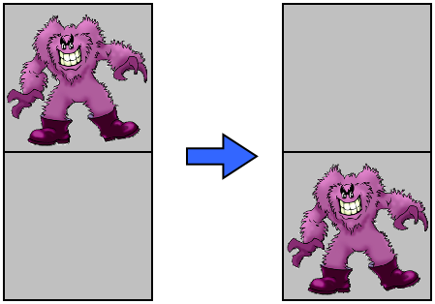
If ___________________________
then, _____________________.

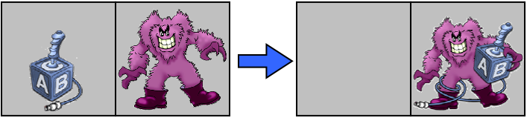
If ___________________________
Then, _____________________.
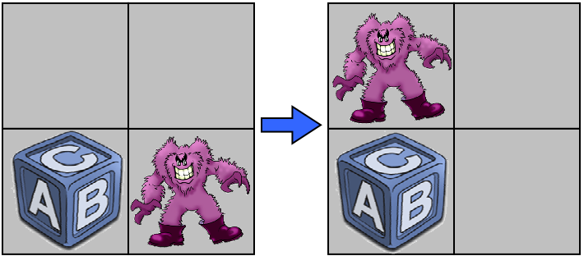
If ___________________________
Then, _____________________.

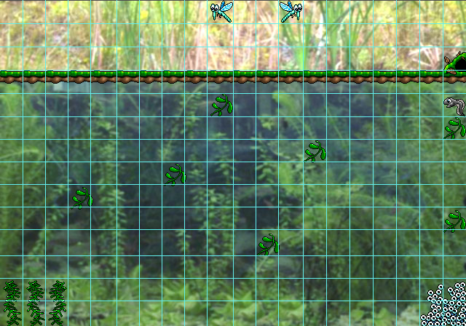
PondLife on a Grid

PondLife on a Grid - Possible Answers

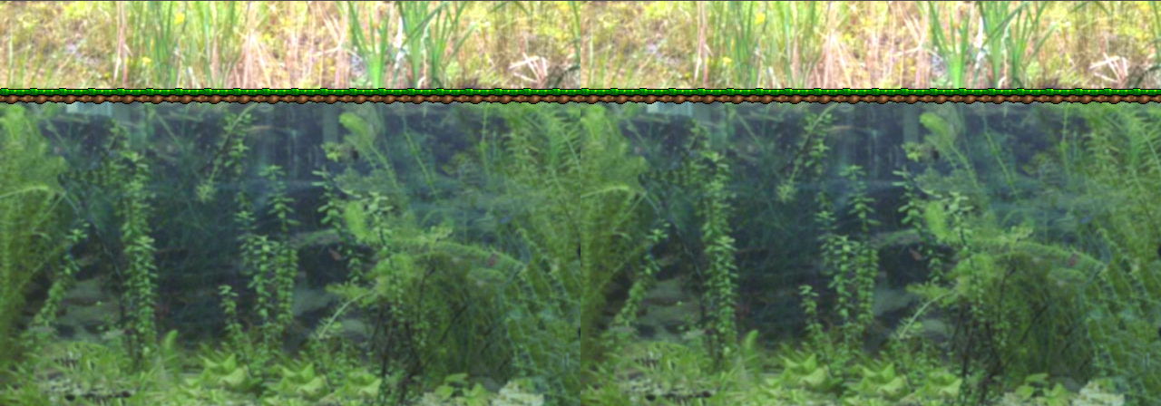
Longer Pond
Blank Grid

Walk Through Careers in Game Design
1. Check out the careers in game design:
http://www.igda.org/breakingin/career_paths.htm
2. Click on Audio, Design, Production, Programming, and Visual Arts to answer these questions in preparation for selecting your team.
- What department or person is in charge of user play testing?
- Which department or person is in charge of quality assurance testing?
- Do you think you will need both user testing and quality assurance testing for your game design?
- Which job pays the highest potential salary?
- Which job pays the next highest?
- What does a sound engineer do?
3. Check out the following profiles:

- Tricia Harris, Web Designer & Writer http://www.igda.org/breakingin/profile_tricia_harris.htm
- Chris Degnan, Lead Designer http://www.igda.org/breakingin/profile_chris_degnan.htm
- Darryl Duncan, Composer/Musician http://www.igda.org/breakingin/profile_darryl_duncan.htm
- Seonaidh Davenport, Program Manager http://www.igda.org/breakingin/profile_seonaidh_davenport.htm
- Douglas Noel, QA Game Test Coordinator http://www.igda.org/breakingin/profile_douglas_noel.htm
- Genevieve Picard, Software Developer http://www.igda.org/breakingin/profile_genevieve_picard.htm
- Tammy Yap, Programmer http://www.igda.org/breakingin/profile_tammy_yap.htm
- Tito Pagan, Senior Artist/Animator http://www.igda.org/breakingin/profile_tito_pagan.htm

Game Design: Who’s in charge?
Design Tasks | What department or person is in charge of this task?
Define problem | market research  designer
Brainstorm
Sketch it
Research it
Develop designs
Create prototype
Build it
Test it
Use it

My Design Dream Team
Pictures go here
Name:
Title:
Role/Job:
Name:
Title:
Role/Job:
Name:
Title:
Role/Job:
Name:
Title:
Role/Job:
Name:
Title:
Role/Job:

Fun & Simple
These principles of game design will help you design your game. Fill out the following chart as you play the maze and the adventure games.
Principle of Game Design | Aspect | Description
Main character that your users can connect with | Characters
Fun, simple layout so that the player always knows where they are and where they’re going | Layout
Clear goal | Goal
Simple way for user to interact with game | Controls
Clear decision making points | What choices are available?
Trade-offs: Every key decision the player makes has both a positive and negative side. | Distractions
 | Rewards
 | Challenges
 | Punishments
Easy way for user to tell whether they are winning or losing. | Feedback

Keeping Track of Rules You Learn
Rule name
Character name
Describe what happens in rule
Starting position & appearance
User input (if any)
Other characters involved in rule
Ending position & appearance
Write the rule
(e.g., If…then…)
Rule name
Character name
Describe what happens in rule
Starting position & appearance
User input (if any)
Other characters involved in rule
Ending position & appearance
Write the rule
(e.g., If…then…)

Designer or Programmer Hat?

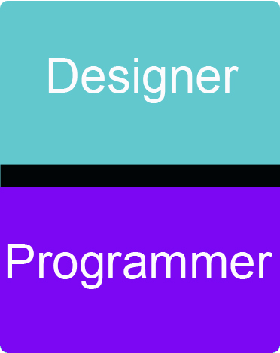

Brainstorming the Big Game
- The first step in creating your game is to brainstorm ideas. Brainstorming is an exercise in pure creativity.
- As you come up with ideas, share them with the group. Listen to what others are saying—listening can help you come up with new ideas, too.
- When you are finished, consider the following

What makes a good first-person game?
- Every game has a main character. The user will control the actions of this main character.
- Every game happens in a specific location, whether imaginary or real. Many games have rooms or stages. (Remember Jessie’s Winter World?) You need to decide on a place or places for your game.
- Every game has a goal. The main character has to solve a need, a desire, or a problem.
- Every game has actions. The central character does something about the need, desire, or problem. This creates a result. The result is the goal of your game. You need to define the tasks before you start designing and programming.
- Every game has challenges. Games would not be fun if the goal were easy to achieve. You will have to think of ways to make the game difficult and fun for the user.
- Every game can be won or lost. Think about what constitutes winning your game (maybe collecting objects, getting points, eliminating the competition).

3. When you are done brainstorming, write down the whole group’s idea for the game:

a. What is the point of your game?
b. What are the challenges for the main character?
c. How will the main character go about winning the game?
d. How does the game end?

Map of the Big Game
Stage 1
Classroom
Stage 2
Classroom
Stage 3
Cafeteria
Stage 4
Gym
Stage 5
Lockers
Stage 6
Library
Stage 7
Field
Stage 8
Bus stop
school
What do you notice in this map?

How can the user go from one stage to the other?

Stage 7
Stage 1
Stage 2
Stage 3
Stage 4
Stage 8
Stage 5
Stage 6
Start
Stage 1
Stage 2
Stage 3
Stage 4
Stage 5
Stage 6
Stage 7
Stage 8
End!
What do you notice in this map?

How can the user go from one stage to the other?
What do you notice in this map?

How can the user go from one stage to the other?

Rapid Prototype of Your Stage
Project Title ___________________________________________________
Use the grids to sketch rapid prototypes of your game.
Include information about the location, the characters, the objects, and the actions taking place in each scene.

Rapid Prototype 1 Location: _____________________________
What does the player do first? Second? Third?

How to Make Storyboards
- Create a sketch to represent the opening scene of the stage. Underneath the drawing explain what happens in the interaction. Write about:
Visual cues—what the user can see
Audible cues—what the user can hear
Tactile cues—what the user can touch
User input—how the user communicates with the computer
Computer output—how the computer responds to the user
Rules—what rules do you have to create to perform this task
- Describe interaction details and emotional responses verbally when no visual representation is effective.
Don’t worry too much about the making sketches perfect; just use them to get the main idea across.
- Do another sketch for what happens next, until you get to the end of your game.
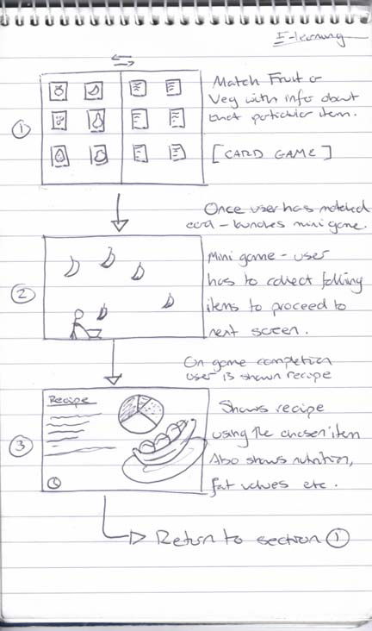
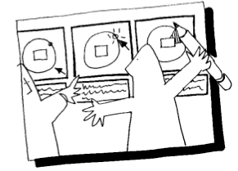
Here are examples of a storyboards. Notice that the drawings are not really detailed. But both the sketches and the explanations help you see what this game is about.

Making Character Rules
Rule Name
Describe what happens in the rule
Starting position and appearance
Other characters involved in rule
User input
Ending position and appearance
Write the rule
(e.g., If…then…)
Rule grouping

People Involved in Testing Games
Here are some people involved in testing games. Some of their work sounds very complicated, but once you do it yourself, you’ll see how easy it is once you get started.
Test Expert
The test expert is the person that owns the process and is responsible for gathering, analyzing, and effectively communicating the information. She should have strong game design, statistical analysis, and test development knowledge.
Internal Customer / Stakeholder
The internal customer is the person who requested the information (about testing the game) and will usually be responsible for developing a portion of the product or providing feedback on it. In some cases, soliciting stakeholder feedback can be used to bring in internal customer perspectives on divisive issues.
Play-Testers (Target Audience)
The play-testers are the carefully selected group that represents the target audience. Selecting play testers for the target audience is an important part of the process.
Play Test-Coordinator
The play-test coordinator is responsible for planning, organizing, and managing the play-test sessions according to the test expert’s requirements. This includes everything from finding the play-testers all the way to ensuring they receive compensation.
Developers
The developers design and implement the tools and technology that allow for the efficient gathering and analyzing of all this information.
The Test Processes And Reports
What questions would you like answered about the product? Many developers want to know how customers are using their products and what they like or don’t like about them.

Extracted from: http://www.gamasutra.com/view/feature/1546/tracking_player_feedback_to_.php

Game Instructions

Team: _________________________________________________

a. What is the way to play the game?

b. What is the goal of the game?

Game Review
When filling out this form, make sure your comments are helpful to the other programmers. Explain your reasons for each comment and suggestion.

Stage reviewed: ___________________________________

- Did the instructions make sense with the game? If not, explain.

- Comments about the graphics:

- Comments about the stage:

- Comments about the audio:

- Comments about the rules:

- What do you think this stage teaches 5th graders?

- How can the programmers improve this game? (Give concrete answers).
Using Scratch Instead of Stagecast
You may want to use Scratch instead of Stagecast. The choice is up to you. Scratch has many resources and tutorials and a large user community. Here we provide some comparisons to help you decide if you want to use Scratch or Stagecast when you implement ICT4me Unit 5. Note that we have not tested the unit with Scratch. We welcome your feedback if you decide to incorporate Scratch.

Benefits & Drawbacks
 | Stagecast Creator 2 | Scratch
Website | http://www.stagecast.com | http://scratch.mit.edu/
Support | Mature software, with on-call support | Community-resource support
Cost | $30 / license | free
Software | Lives on your computer.  Stable version 2. | Can download software to computer, and can also use online.  Currently version 1.4, but version 2.0 is in development, beta available for use online.
Materials | Book and pdf with curriculum ideas;  Online community of users;  Tutorials and sample games to program | Huge online community, offering tutorials, information for parents and educators, tutorials, examples, etc.
Examples | Good game examples, made by publisher and other curriculum developers; strong educative value. | Search site to find examples from community, of varying degrees of sophistication; nor particularly educative.
Programming | Object-oriented programming. Stagecast is a visual programming environment. Users use the location of sprites (characters) on the screen to create rules. Whatever situation is present on screen will determine how the rule is made.  If / then framework applies to all the rules.  Order of rules is important. | Object-oriented programming. While Scratch is also visual programming, language is more prominent than in Stagecast – but most codes are already provided. Users are scaffolded in using the language-based commands with “fill in the blanks” scripts.  Not all rules involve using an If / then framework.  Order of rules is important.
Sharing | Online. Users have to download the player (free) to use a Stagecast program. | Online.
Putting multiple Stages / Levels together | Requires a little help from instructor, but it’s easily done, if following unit 5 instructions. | Not tested. It’s possible. Instructor would need to find out from the Scratch tutorials and community.
Programming by | Rules | Scripts
Characters | Characters / Sprites | Sprites
Navigation to next stage / level | Door | Next Level Script
Background Stage | Stage | Level
How to start | Green Arrow | Green Flag

Week-by-Week Recommendations
Here are some specific recommendations for using Scratch. Some weeks, like 3 and 6, do not involve programming, and thus there are no specific recommendations for using Scratch.

Week 1: Programming vs. Playing Game
Challenge: There are many programs that youth have created available on the Scratch website. Most would not be considered games. Find three or four Scratch games for youth to play. Consider types of games, sophistication, leveling, and appropriateness in your choices. In particular, we want to provide two types of game situations for youth to explore: mazes and adventure games.
Main Activity: Use one of the games you found, or use a new one (or create one yourself), without any rules, so that you can demonstrate how to program (in a whole class situation). With enough time, you can recreate the Monty Mole game in Scratch.
Discussion/Reflection: From this point forth, where applicable, refer to Scratch rules or scripts learned.

Week 2: Learning Stagecast with PondLife
Challenge: Find an existing game to demonstrate rule creation, or use one of the tutorials from the Scratch website.
Main Activity: Do the first part of Math Activity option 1 (playing battleship with the idea of coordinate plane), and then proceed Math Activity option 2.

Week 4: Principles of Game Design & Stagecast Tutorial
Main Activity: Replace Stagecast Tutorial with Scratch Tutorials from educator resources.

Week 5: Designing the Big Game
Main Activity: Replace Stagecast Tutorial with Scratch Tutorials from educator resources.

Week 7: First Week of Programming - Week 12: Sixth Week of Programming
Activities: Use Scratch for any programming activities.

Week 13: Putting Humpty Dumpty Back Together Again
Getting Ready and Activities: You will have to research how to put together multiple games in Scratch. There may be some tutorials available, but your best bet is to ask the community.

